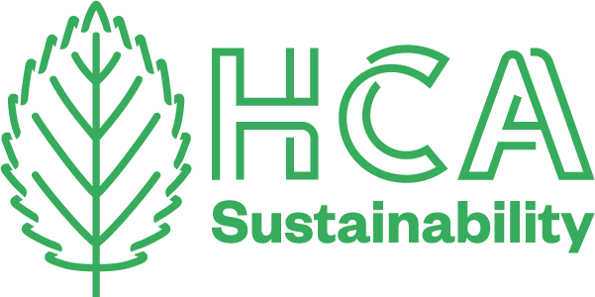
HCA Sustainability Newsletter

May 2021
We’ve been busy bees since the last newsletter, celebrating Fashion Revolution week, attending conferences and finding more sustainable alternatives around the college.

AOC CONFERENCE FEEDBACK
Three members of the sustainability committee attended the Association of Colleges conference this April. It was called Protected: Climate Change and the Green Economy Conference – Preparing for the future. These are some key points we took from the sessions we attended: -

Nick Thomas, BA Textiles Course Leader
I joined the Curriculum & Student session which covered the Carbon Literacy education programme, COP26 and lived experience insights from principals and governors of FE providers in East Sussex.
- The new Carbon Literacy curriculum has been adapted from the existing HE materials and developed for FE students, and staff. It is being trialed at key institutions in May, ready for a national rollout from June. The course can be delivered across 8 hours, including bite-size sessions with full certification being available on completion.
- COP26 (the UN Climate Change Conference) will take place this year in Glasgow, 1st - 12th November. Given its location, all eyes will be on the UK, which provides an opportunity for colleges like ours to engage in these important discussions and work to embed this event into our teaching and learning.
- Principals and Governors alike expressed how the student voice has been instrumental in embedding sustainability targets and goals into wider strategic planning. One principal remarked that recent applicants had even been asking what the college’s sustainability roadmap looked like, demonstrating how important this issue is to incoming student bodies.

Alison SlogGETT Earl, Print Workshop Technical Demonstrator
I attended the introduction talk where there were lots of inspiring institutions that spoke about how they were tackling the road map to carbon neutrality. Each college or university has its own unique problems to solve but it was interesting to hear some of the actions they have put in place. From simple things to led light bulbs throughout, to installing and investing in massive solar panel installations, which has then paid for itself with the savings made from energy bills.
I then listened to the session on Green economy and technology.
Wirral met college did a case study on their investment in a low carbon hybrid energy center. The Key points were: -
- They had the support of local government as it would help Liverpool city region reach their carbon neutral targets.
- As they were leading the way for using this relatively new technology they put in, they made sure the energy center was also able to be used as a teaching space.
- It was a big investment, but they can now heat the largest campus, and cover 80% of the electricity, with this low maintenance system. Which has or will allow them to make saving in the running costs of the college which then allows that money to go back to supporting the students learning.
The next speaker was an independent technology analyst, who talked about various ways technology could help tackle issues we have, for example software that could help monitor and reduce small appliance energy usage, or Dryad, a program helping to predict forest fires to help some from taking hold and thus reducing carbon emissions.
The final speaker talked about preparing for the green economy. Looking at greening current courses and the creation of new courses to help train people in new technologies. As this will be the norm and culture of the future.

Jess Bugler, Print Workshop Technical Demonstrator
I attended the session on Civic Leadership, Governance and Culture, which included presentations from 3 different colleges and discussed how they had managed to embed sustainability into their colleges. The key points I noted from the presentations were:-
- The importance of sustainability being led from the top of the college and embraced be senior leadership and Governors.
- The importance of keeping the commitment to sustainability high profile and embedded into all strategic planning.
- The need to involve everyone and for it to come alive in everything needs to be repeated and embedded into everything……it takes time. Have a plan, review it and do something with it!
- Finally, to acknowledge that this is a fork in the road and there will be some transactional pain but the cost of doing nothing will be far more painful for all..
- And this sobering Graphic stuck in my head....
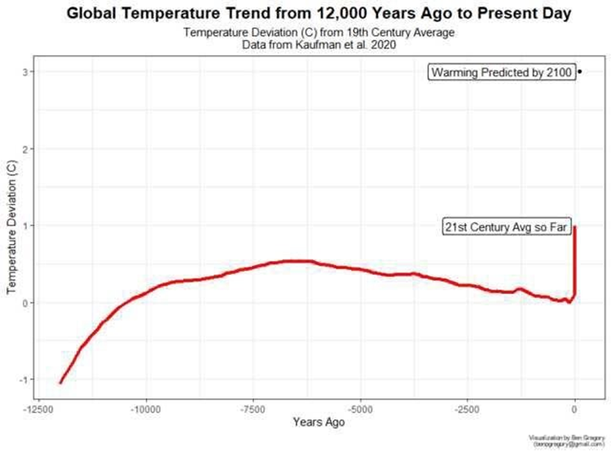

fASHION REVOLUTION WEEK
Nick Thomas
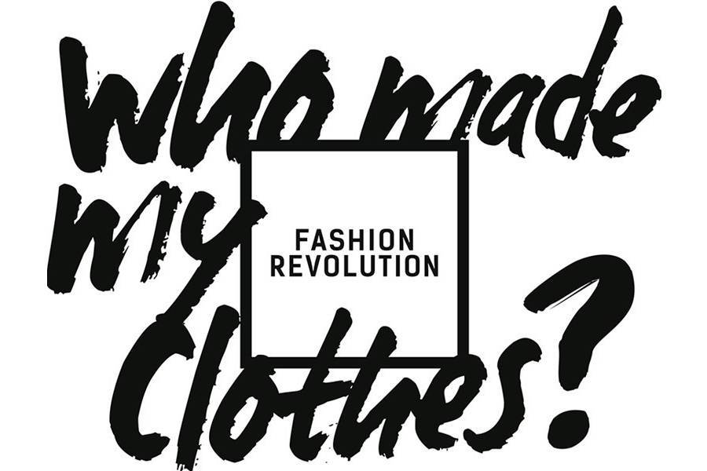
2021 saw HCA take part in Fashion Revolution Week for the 4th year, and this was our strongest yet! We had activities happening across the college including a socially distanced Clothes Swap, an up-cycling twine workshop and visiting speaker Charlotte Cameron (founder of Berjoan), who shared her own insight into sustainable design within the fashion and textiles industry.
Alumnus John Sanders, and current final year Dagmara Chwalik, also joined us for a panel discussion where they talked about how they are addressing sustainability within their practice including working with organic matter and deadstock fabrics from warehouses.
As we know, it can sometimes feel overwhelming when we think about how we can make a difference to what is a huge topic, but I certainly came away feeling confident that small, individual changes genuinely do make a difference; and buoyed by the knowledge that our students are proactively working to make the world a better place!

ICYMI...
On Tuesday 20 April, a panel of staff, students and graduates met to discuss Sustainability in Textiles as part of Fashion Revolution week. The conversations which followed were thought-provoking and fascinating.
Panel members were Nick Thomas, Course Leader for B.A (Hons) Textile Design at HCA, Dagmara Chwalik, textile design student at HCA, John Sanders, recent graduate from HCA and Jess Bugler, printmaker and technical demonstrator at HCA.
Catch up with bitesize videos of the discussion online!
- Panel Discussion Sustainability in Textile Design@HCA 1- Meet the Panel (3 mins)
- Panel Discussion Sustainability in Textile Design@HCA 2- Why textiles is important to the sustainability agenda (5 mins)
Panel Discussion Sustainability in Textile Design@HCA 3. How do you make sustainability fashionable? (3 mins)
- Panel Discussion Sustainability in Textile Design@HCA 4. How to be pro-active about climate change without getting overwhelmed? (7 mins)
- Panel Discussion Sustainability in Textile Design@HCA 5. What effect might lockdown have had on the sustainability in textiles agenda? (8 mins)

Clothes Swap
Kath Ayres
In support of fashion revolution week the Students Union hosted a clothes swap event in the café at our College Road campus on Thursday 22nd of April.
This successful event brought students and staff together to discuss and share information around fast fashion and sustainable practices and of course swap and find a new home and use for once unwanted items of clothing.
We were lucky enough to have a large number of generous donations in clothing from staff and students, for people who did not have any items to swap they were able to make a small donation and take some items of their choice. The event raised £40 in donations, which has been donated to Fashion Revolution week in aid of all their charitable work; they support charities such as anti-slavery international, Fairtrade federation, Greenpeace and many more.
The Student Union plan to run another clothes swap event at Folly Lane campus in the coming months!

Student perspective
Charlotte Crossley, L6 Textile Design
During fashion revolution week, we had a great talk from guest lecturer Charlotte Cameron, who shared her experiences within the fashion industry and discussed the sustainable challenges we are facing. Charlotte focused on the positive steps that have been made in fashion companies over the past few years and how we as designers can go on to make responsible choices. During lockdown 2020, Charlotte launched her new business, Bejoan. Bejoan’s ethos inspires consumers to reflect on the connection and stories they share with their clothing, as well as finding value in the pieces already in their wardrobes, embracing slower fashion.
Some of the key take aways from the talk were
- To keep challenging fashion companies on how they are being sustainable and if they advertise a product as being sustainable, question how it is sustainable.
- Look and consider how you could source your materials locally
- Seek collaborations with people who have the same ethos as you and work together to produce responsible and traceable designs
- As designers it is our responsibility to know the environmental impact of the materials we use, take a considered approach and problem solve where needed
- Consider what elements of sustainability are most important to you and focus on tackling those areas within your work.
- There is hope for a better, fairer fashion industry but we as consumers and designers need to continue working to make it happen.

habitat survey
Ian Pennell
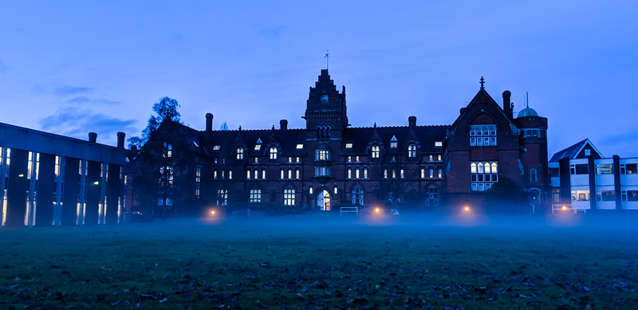
Increasing biodiversity at HCA is an important part of a sustainable college, both for its own sake and as a sign which shows the college is taking seriously the need to move to a more sustainable future. In practical terms this will mean that the college starts to look like a place which encourages and sustains local wildlife both plant and animal, in its grounds and around the outside of the buildings. Spending time in green spaces is increasingly recognised as having benefits for mental and physical health, and more wildlife at college would be good for us all.
Some people at CRC may have noticed the loud return of the swifts this week (mid May). They love the tall central building with its nooks and crannies which provide nesting possibilities, and their annual return from Sub Saharan Africa is a welcome and mood lifting sign that Summer is on the way after a long winter. This is a small example of how visible wildlife can enhance the environment of the college for everybody.
The starting point has been an ecological survey of both CRC and Folly Lane campuses including the Folly Foundation building, which was recently carried out by Anna Gundry from Pure Ecology. The survey gives us a picture of what plant and animal wildlife is here now, and the potential for the future.
The overall message from Anna’s report is that if parts of the grounds can be allowed to become a bit less manicured and more shaggy, it will provide opportunities for wildlife to come in and thrive. An example is the main lawn at the front of CRC. This could be an area shared between the needs of the college community for recreation, sport and so on, and a less managed area towards the far end of the site where different mowing and planting plans can encourage a wildlife meadow to grow, perhaps with mown paths and a pond with seating for people to wander through and enjoy. This would have lots of possibilities for creative design ideas in many college course areas.
A meadow, combined with nest boxes for birds and bats in the trees, log piles in the undergrowth for beetles and fungi, and bug hotels for bumble bees, would transform the rear of the lawn area whilst maintaining the front as mown lawn for amenity use by the human component of the ecosystem.
Hedges can be planted, for example on the College Road boundary, or left to grow thicker and taller prior to later laying at Folly Lane. This would encourage nesting birds and give wildlife such as hedgehogs protected corridors in which to roam.
At the rear of the Foundation building the bare area could be furnished with planters for herbs and wild flowers to attract pollinating insects. The small area of grass could contain fruit trees with Herefordshire heritage apple varieties for people to enjoy at the start of the Autumn term.
These are just some of the ideas about how the college could become more wildlife friendly. For those interested in the detail, take a look at Anna’s report via the link below.
Ian Pennell
Read the survey in full here

RECYCLED PAPER PILOT
Lily Morris

100% Recycled A4 paper is now available to use in any laser printer across the college, if requested.
The paper is made from 100% post consumable waste so has an off-white colour. It is most suitable for printing black and white, since it will not give a true result for colour printing. We will still provide the white copier paper for all photocopiers, but if your work doesn’t need to be on bleached white, please ask for recycled. It is also a more cost-effective alternative! Staff can ask Reception as per usual for paper stock ups for their office/department printers.
On average, the college uses 25000 sheets of paper a month - please always think before you print!
- Can you print double sided?
- Cancel the job before it prints if you’ve made a mistake
- Does it need to be that big?
- Use recycled if it’s black and white, or if you don’t need bleached white
This is a pilot – so please do request and choose this paper when you can!

SUSTAINABLE VIEWPOINTS

“They survived on lentils and slop”
Alex Gordon
We are told that one of the biggest actions we can take as individuals to cut our carbon footprint is to reduce how much meat, fish and dairy we eat. Alex Gordon writes about his personal experiences of veganism.

My name is Alex and I teach music on to level 2’s and 3’s here at HCA. I am not a Vegan but I have had a thoughtful and nuanced approach to what I eat for nearly 40 years now and thought I might try and make some sense of it here.
I had always been an animal lover (most people are) but as I got to 15-16 I also began developing an interest in politics – the miner’s strike was in full effect and Thatcher’s Britain seemed to be wrenching us out of our communities and pushing individualism as the new aspirational dream. I got into anarcho-punk bands Crass and The Dead Kennedys. A big part of what these bands sang about seemed to be rights and power abuse and Crass in particular were known for their vegan/hunt sab/anti-animal testing stance. I studied Economics and Politics at college and was fascinated by power relationships. The relationship humans have with animals seemed to 16-year-old me to be exploitative and an easy target for my angst!
The upshot of this was that I (and probably around 1 million others in the mid 80’s) went vegetarian (and sometimes pescatarian). I think that this decision was really indicative of my black and white and partially formed attitude. I will never again eat something which has a face! Except a fish. Sometimes.
I liked cheese and eggs and had no idea of the processes involved in the production of this food. You could call it lazy thinking. You could call it cognitive dissonance but remember, it was the eighties. You couldn’t look at films of chicks going in the masher at the click of a mouse.
I was in the punk scene and often met Vegans – they were like a weird, hardcore tribe who went through your cupboards if they came round your house and pulled out products containing exploitative ingredients and waved them at you! And the food they ate was not like it is now- they seemed to survive on lentils and slop. I was a kid- immature and not that thoughtful. Also weak!
I guess the next big bit of learning for me was touring abroad with bands in the early 90’s squat scene. Some of these German and French punks were vegans who knew so much more about the connection between environmentalism, economics, class and food. They could cook too! Squat food in Europe was so good. I tasted salad dressing for the first time and smelled real coffee.
These new and uncomfortable feelings that maybe I needed to challenge myself further on food reached their zenith when I toured America and hung out with an amazing anarchist publisher named Craig O’Hara who was on the road trip working for AK press. He nicknamed me ‘prawny’ when we went for a Chinese meal and I had shrimps in my chop suey!
I did not want this nickname and went vegan on the spot. I survived the tour on subway salad sandwiches and, on return to the UK, managed to stick it out for a year – eating lots of rice, stew and beanfeast (a dried vegan flavoured TVP packet dish) before succumbing to some delicious blue cheese from Shropshire called ‘Black Sticks’.
Fast forward now ten years - my wife and I had been members of Greenpeace and had campaigned for various left leaning causes. We got interested in communal living and ended up moving to an intentional farming community in Herefordshire called Canon Frome Court with our two boys. This wonderful place has a collectively run smallholding/farm and we entered a phase in our life where we learned about organic farming practices and worked with goats, cows, sheep, pigs and chickens.
I threw myself into this and decided to eat meat produced on the farm to the highest organic standards- this is after being veggie or vegan for the previous 20 years! I milked goats and cows, slaughtered chickens, sheep and goats and really started developing my ideas on sustainable agriculture. For 6 years I believed strongly that mixed agriculture could and would be an important element of the transition to a sustainable future.
But things kept cropping up which just didn’t fit. I began to think in more detail about carbon and my thinking around arable farming, permaculture and the use of green manures and closed farming systems developed. At the same time the old thoughts about exploitative power relationships kept coming back when I saw close up how a herd of cows live together and the pain they experience when their calves are taken away or when there is a slaughter on the farm how scared the animals get- and this was in a caring organic farm which strictly kept to organic care standards nevermind in the majority of commercial farming operations. When you care for cows you really begin to get a sense that they are in bondage to you.
Finally, in 2013, the cult Ska Punk band ‘Culture Shock’ reformed and I was lucky enough to be asked to play guitar. The job of a lifetime!!! I decided that I would go full vegan again as we sang about animal rights in our songs and I didn’t want to do that without walking the walk too! When we toured I noticed there was so much more choice now – tempeh, vegan burger shops, vegan donuts, seitan, burritos- the list was long. When I toured again in the US I was amazed- vegan iced coffee, massive vegan supermarkets with delicious bakery products and deli’s - awesome! Our roadies Karoline and Robert were the coolest vegan couple and took us to the best vegan restaurants in all the towns of the tour- Chinese, Vietnam, Mexican, Italian -so lucky!
So here I am now in 2021. Still interested in food politics and I love cooking. We have our own bit of land where we grow as much veg as we can using no dig and permaculture principles as far as possible. I eat eggs from a neighbouring farm, when out to dinner I will eat cheese if my host was not aware of my preferences and, if I’m in a staff meeting I will not turn down a bourbon biscuit. A counter-revolutionary!!

“I do feel a bit guilty” - a review of Seaspiracy
Lily Morris
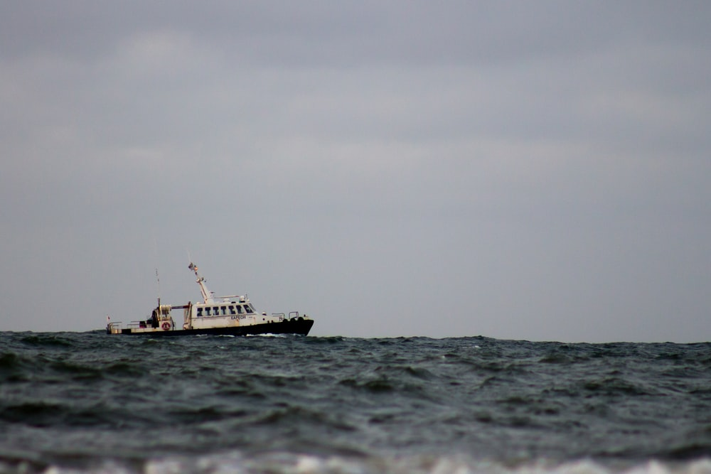
It was a recent most popular on Netflix, Lily Morris watched Seaspiracy and shares her thoughts.

It’s one day when I’m not working on Reception at Folly Lane. The sun is shining brightly outside but I’m just not feeling like getting out of my pyjamas or opening the blinds. Netflix goes on. Da-daah. I mindlessly slide through the tiles for a while until I decide that if I’m going to be a waste of space, I might as well educate myself. Documentaries > Released today > Seaspiracy.
Ali Tabrizi, a young British environmentalist and filmmaker, seeks to answer questions about sea plastics, but ends up on an entire new odyssey and down some, sometimes dangerous, rabbit holes. He investigates Japanese whaling, slavery at sea, the farce that is ‘sustainably sourced’ labelling and not so sustainable alternatives, like fish farms. I’ve not seen the unofficial prequel Cowspiracy, so this was the first big Netflix production I’ve sat down to watch on the concerns with global food production, but I anticipated it would probably be hard to swallow (even for someone who already doesn’t like the thought of eating animal corpses very often). OK, so I’m no red meat eater, but I used to crush a tuna and sweetcorn sandwich in my daily Tesco meal deal when I was studying in Nottingham. Nowadays, I’m just a bad vegetarian. Oat milk is a staple in my fridge - then again, I am a millennial… I enjoy having a variety of foods too much to exclude some of my favourites and call myself a full-on vegan - I just don’t have that sort of self-control (chocolate is my Achilles heel). It’s not been in recent years, when I’ve watched or scrolled past videos about where our food comes from that I’ve become aware about the environmental impacts of it all. I was fortunate enough to be raised in Herefordshire, choosing to respect where our food comes from and buy the best we can afford. As a scrimping student, convenience and value is key (with the occasional indulgent spend when the loans come in). But now I try choose the right product to spend my money on and stop to think much more about nutritional value, the quality of the produce, where ingredients are sourced and any farming/welfare issues - let alone the packaging! So I knew it was bad, but I wasn’t expecting this.
Seaspiracy made my skin crawl. After watching all 1hr 30, I didn’t want to touch the Scottish smoked salmon in my fridge, knowing the sea lice that could have already had a nibble. Or the false colourants added to make the flesh look healthier. Or how many others it was crammed in the nets to swim in circles with. Or that the farm it came from was contributing to so much organic waste being pumped into the North Sea! – it’s estimated the Scottish salmon farming industry produces organic waste equivalent to the entire population of Scotland each year… Then there’s the whaling. Ali and his wife travel to Taiji, Japan where fishermen and police are working together to disguise the numbers of whales and dolphins which are slaughtered in the small bay there most days. The dolphins are eating the fish stocks which the fishermen need to catch to earn their living - but that’s no excuse to take the lives of so many individuals. He later visits the Faroe Islands to investigate ‘sustainable whale hunting’. Now, I’m a stickler for tradition and The Grindadráp has been going since 9th century. It‘s also become a Faroese ritual as young, first-time hunters ‘become men’- but this gets very graphic. The bright red shoreline is very upsetting. However, the locals only hunt a few times a year, or not at all sometimes, and they utilize every part of each whale to keep them going for the next few months. It’s romantic in a historical way, and can also be argued that it’s not disturbing the local ecosystem in such a detrimental way as it is in Japan, so perhaps it can’t be that bad?! Whatever your opinion on eating fish, you cannot ignore the realities about slavery in the fishing industry which are revealed in this film. Ali interviewed escaped slaves in Bangkok, one of which was had been kidnapped and kept at sea for 10 years. Another, so depressed, had tried to take his own life three times. The way young men were, and still are, treated on fishing boats is abhorrent and immoral, and should never be the price consumers pay for cheap, convenient seafood.
I’d watched this film before I’d read any of the scathing articles that were published online after its release in March. Some criticized the reputation of the ‘experts’, others said the wrong people had been interviewed from the large corporations, which subsequently showed them in bad light, but of course they’d say that! Some even said it was just another scaremongering documentary by veganazis to make us all feel terrible about our life choices, depressed about the state of the world and lose all faith in humanity. You watch it and decide for yourself. Personally, I’m convinced by the facts and trust the research and opinions of the experts involved. In fact, it was nice to recognise some of the organizations I’d studied in my sustainability module at uni in 2016, and that the all the overwhelming issues attached to climate change and globalization had not worn thin with them yet. The doc concludes with: “Don’t eat fish, there are vegan alternatives now in 2021.” Kinda obvious (I love seaweed). But it did remove every ounce of confidence I had in food labels and how some of the big establishments are trying to ‘protect’ the oceans. All I can think is ‘if everyone who watches this can change a little, surely that might help?’ So I’ve recommended this to a lot of my friends, from vegans to carnivores. Sure, it gets pretty explicit and I can’t deny it did leave me feeling a bit gloomy, but it has continued to make me consider my choices when ordering food and shopping. No, I’m not going to tie myself to any boats any time soon, but I can choose what I spend my money on.
At the time of writing, I’ve eaten two pieces of fish in the month since watching Seaspiracy. And I do feel a bit guilty. Better get back under my blanket and watch something cheery. Da-daah…

ST Recommends…

MAKE
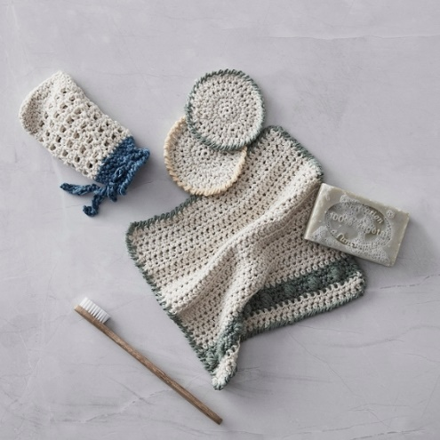
Crotchet a Reuseable Washcloth set

BUY
Circular&Co. Reusable Coffee Cup

£11.95 – £12.95
- The world’s first, 100% leakproof reusable coffee cup, made from single-use paper cups.
- Designed for 10 years use, Circular Reusable Coffee Cup is 100% recyclable.
- Made in Cornwall, the company also has a takeback scheme for used/faulty products to reduce waste!

read
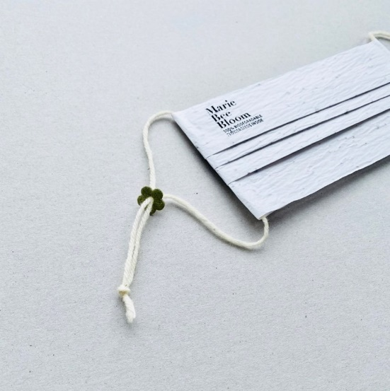
Dezeen: Flower Seed Facemasks

get in touch
Email us on sustainability@hca.ac.uk
Instagram @hca.sustainability
Join the team! Send us an email to get onboard and make a change…

