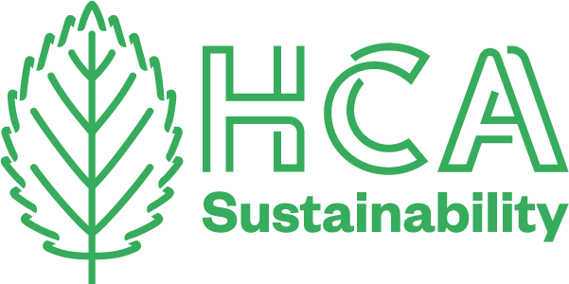
HCA Sustainability Newsletter

JULY 2021
In our final newsletter of this Academic year – we want to celebrate the final shows across FE and HE and highlight some of the great work around sustainability by students and staff.

HANGING SUSTAINABLE SHOWS...
Claire Burgoyne
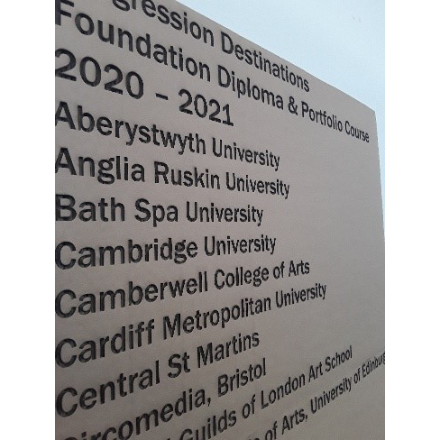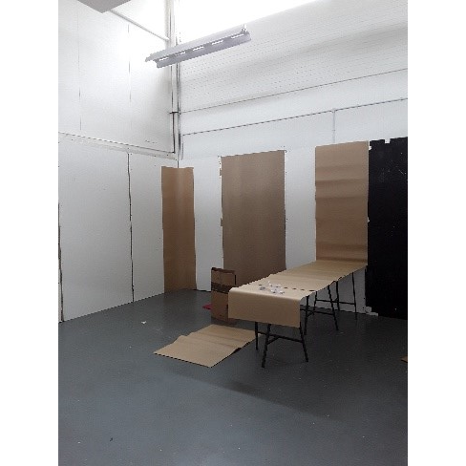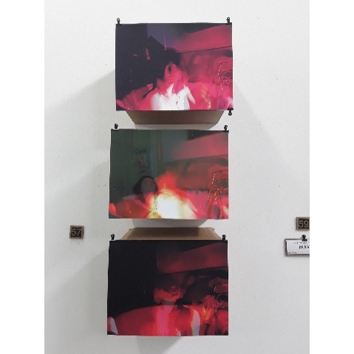
The Foundation team this year decided that the show should be as sustainable as possible carrying on with the ethos from Lockdown. We felt that we wanted to play our part in promoting sustainable practices and find alternatives when curating and presenting a show.
Throughout the year we had been impressed with the students’ capacity to be resourceful in terms of the materials they had found and used when making their work whilst at home.
With this in mind, we started work. Our FAD studio space is a blank canvas and we decided that we didn’t want to paint the walls but have a raw quality to the space. We spent time configuring how we could construct the show that felt cohesive, but still offer presentation opportunities that didn’t compromise the students work. Using creativity to turn “waste” materials back into resources. We reused and re-purposed cardboard boxes, magazines and retired climbing ropes donated by local businesses as they were no longer fit for their original purpose as a way of hanging and displaying the student work.
We wanted to explore and expand on alternatives to printed paper and used Laser etched cardboard to continue the theme of the show but still with a professional feeling. We also took the decision to use a QR code to access the student’s artist statements, rather than printing them out individually, which in turn also directed visitors to the college website.
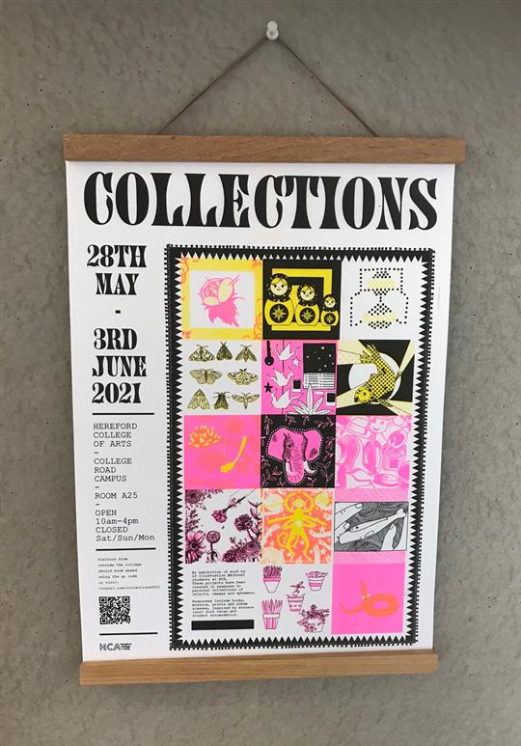
In HE, the Illustration Department were also trialing wooden poster hangers that can be used each year and remove the need for the unrecyclable foamboard.

highlights of degree shows
PHOTOGRAPHY AND FINE ART
Ian Pennell.
Sustainability was a thread that wove through the degree shows for BA Photography and BA Fine Art, both in the subject matter and in the use of found and recycled materials.
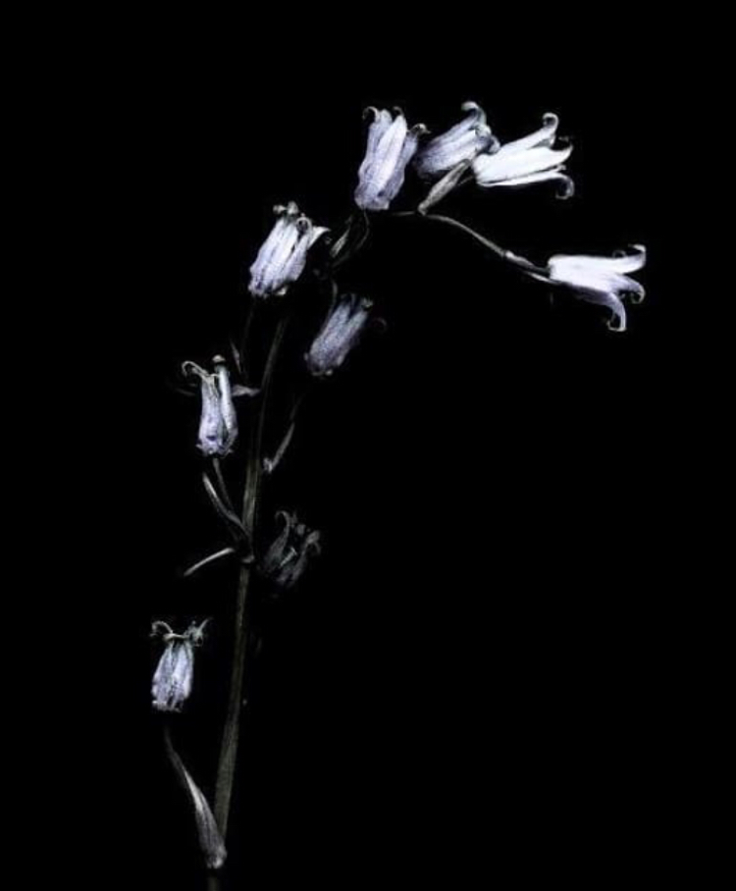
William Pettit’s subtle images of bluebells from ancient woodlands threatened by the construction of HS2 evoked the vulnerabilities of the natural world in the face of our continued demand for “progress”, and the ironies of producing environmental destruction in order to create what might be thought to be desirable public transport systems, showing that nothing comes for free in our technological world.
William Pettit, image from “Endymion’s Lament.”
Several photographers showed collections of images portraying in various ways the natural landscape and our place in it, Alexis Sinclair, Joelle Higgins, Matt Davies, Miles Goodwin, Bethany Spicer and Daisy Morgan among them. Others, including Alex Thomas-Bates in images of nature reclaiming parts of the Rotherwas munitions site, shows the impermanence of our human presence. Nature will win out in the end.
In the Fine Art show, Shelley Slark reused her own childhood books and soft toys, and found objects in the form of used birds’ nests in work evoking her own sense of empty nest. Isobel Vickery used animal bones to create both 2D and 3D pieces in her work “Life/Death/Life.
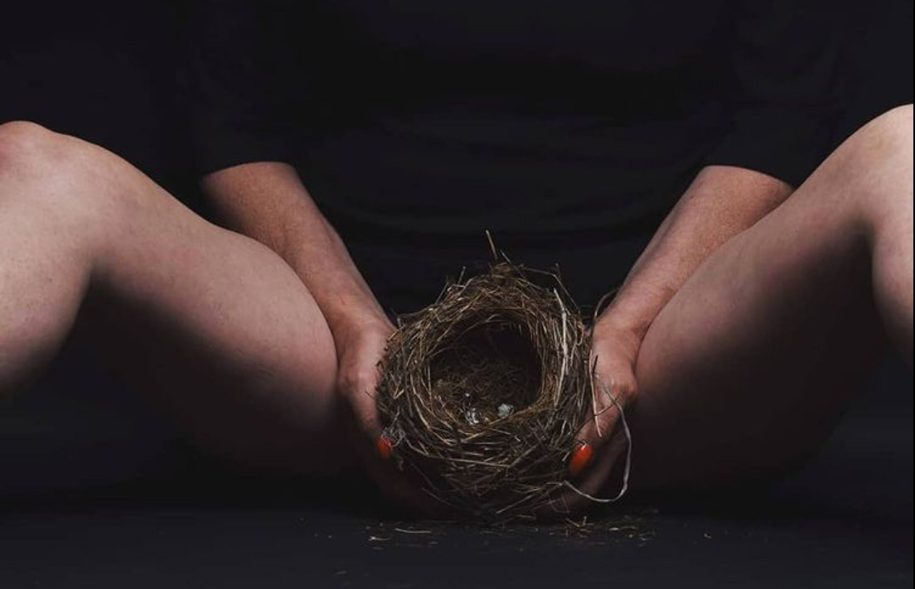 Shelley Slark. Empty Nest.
Calum Wright showed an explicitly protest piece on themes including climate change, whilst Deborah Gould’s installation graphically interrogated the industrial farming involved in producing our daily milk supplies.
In both degree shows it was obvious that ideas about sustainability, biodiversity and not wanting to contribute more to the mountains of new “stuff” in the world are a continuing source of inspiration for HCA students making interesting and engaging art.
TEXTILE DESIGN
Nicholas Thomas
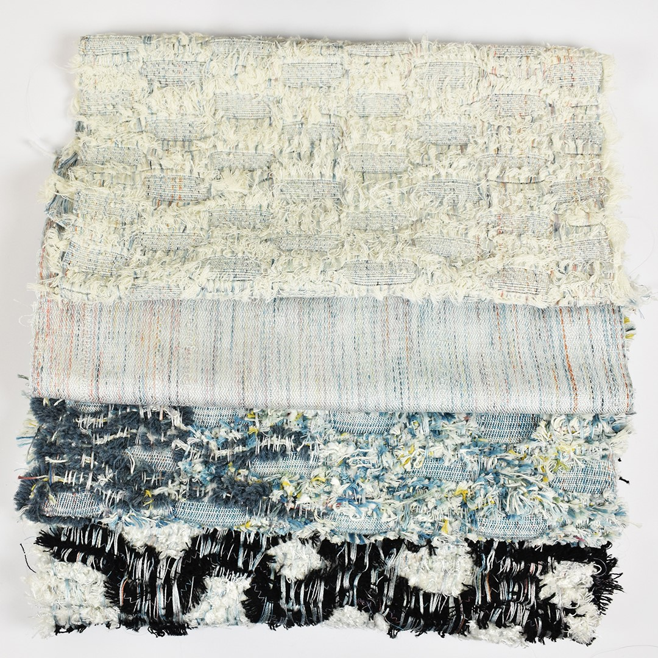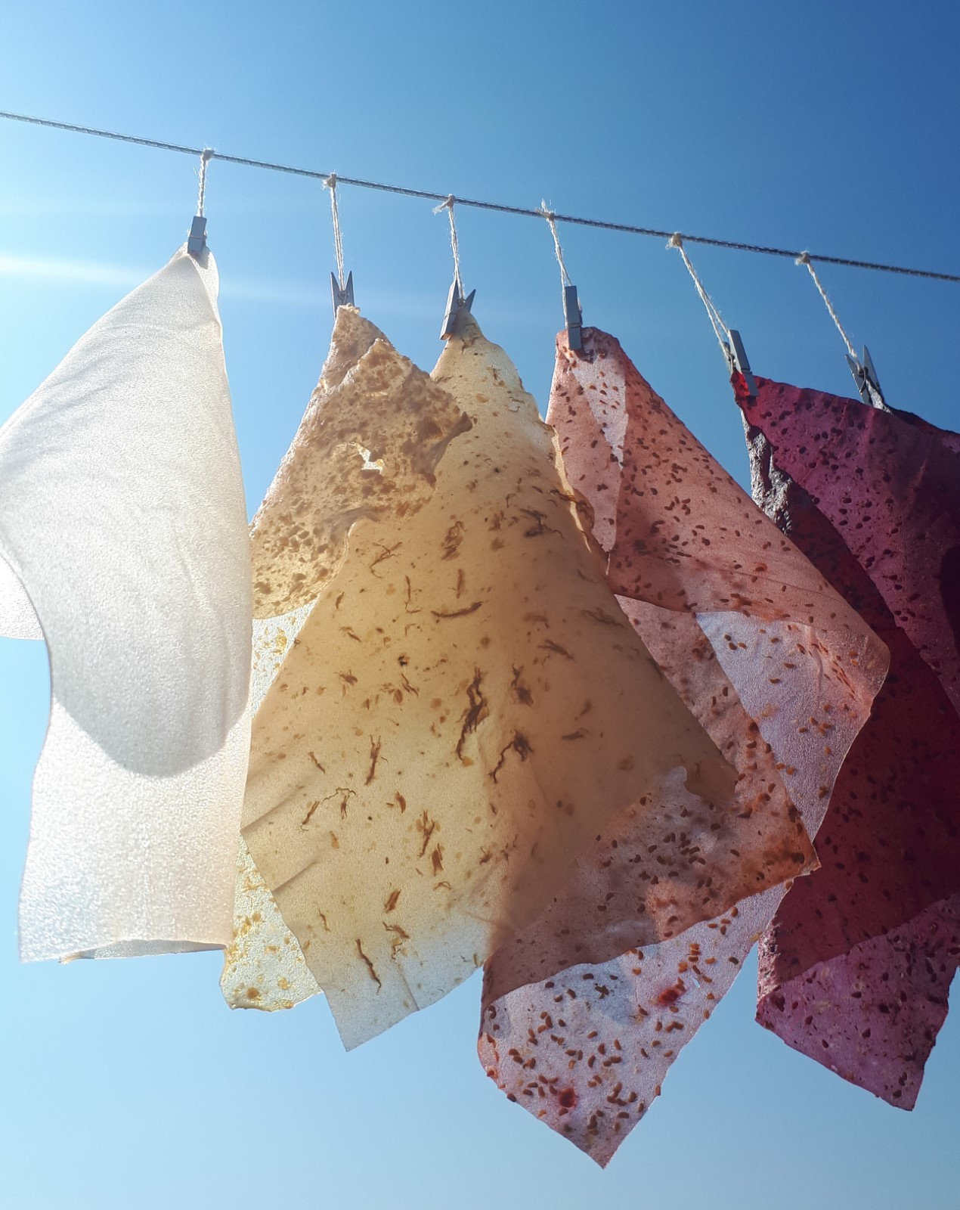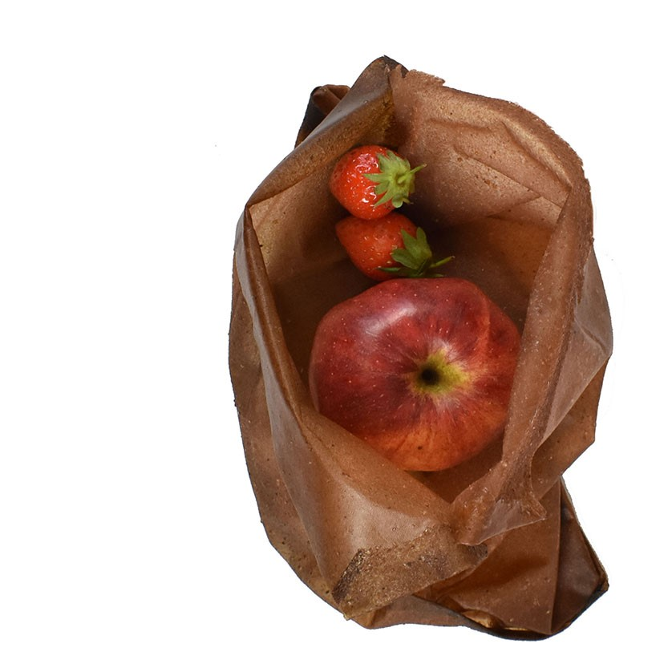
Dagmara Chwalik, Christie Farr, Ellie Preece,
Unravelled Fashion 2021 Edilab 2020 Kitchen Archives, 2021
This year’s graduates once again showcased the power of authentic, sustainable design thinking within contemporary Textile Design practice. From food packaging solutions made from fruit leathers to woven and knitted fabrics that championed the importance of personal wellbeing, the show’s strong aesthetic value was underpinned by an even greater body of meaningful research.
Students were delighted to walk family and friends around the space, not only to talk about their own projects, but those of their peers too, celebrating shared achievements. Described as “joyfully pandemic-free" by one visitor, the work on display was rich in colour, pattern and texture, with many drawn to touch the pieces on display; a real tactile delight after what has been a challenging fifteen months.
Alongside the class of 2021, a selection of last year’s graduates joined the show as part of ‘One Year On’ which was a real highlight for staff and students alike, having been the first time their body of work was seen in physical form.
Some highlights of the show included, ‘Unravelled Fashion’ by Dagmara Chwalik. Dagmara transformed deadstock tweed fabrics turning them into beautiful yarns that were woven through hand painted silk warps. Her stunning collection of ethereal samples showcased just how beautiful ‘old waste’ can become.
Ellie Preece (2021) and Christie Farr (2020) both explored the rapidly evolving subject of biomaterials in their projects, one for fashion and one for product. These compostable and bio-degradable fabrics will soon be commonplace in our lives, so it was fascinating to see similar materials being developed with different end-uses in mind.
CONTEMPORARY CRAFTS
In Contemporary Crafts Milicent Sutton created work that addresses environmental degradation looking for new outcomes that can work in harmony with our changing planet. She hopes to discover “new materials” with the potential to contribute to a circular economy.
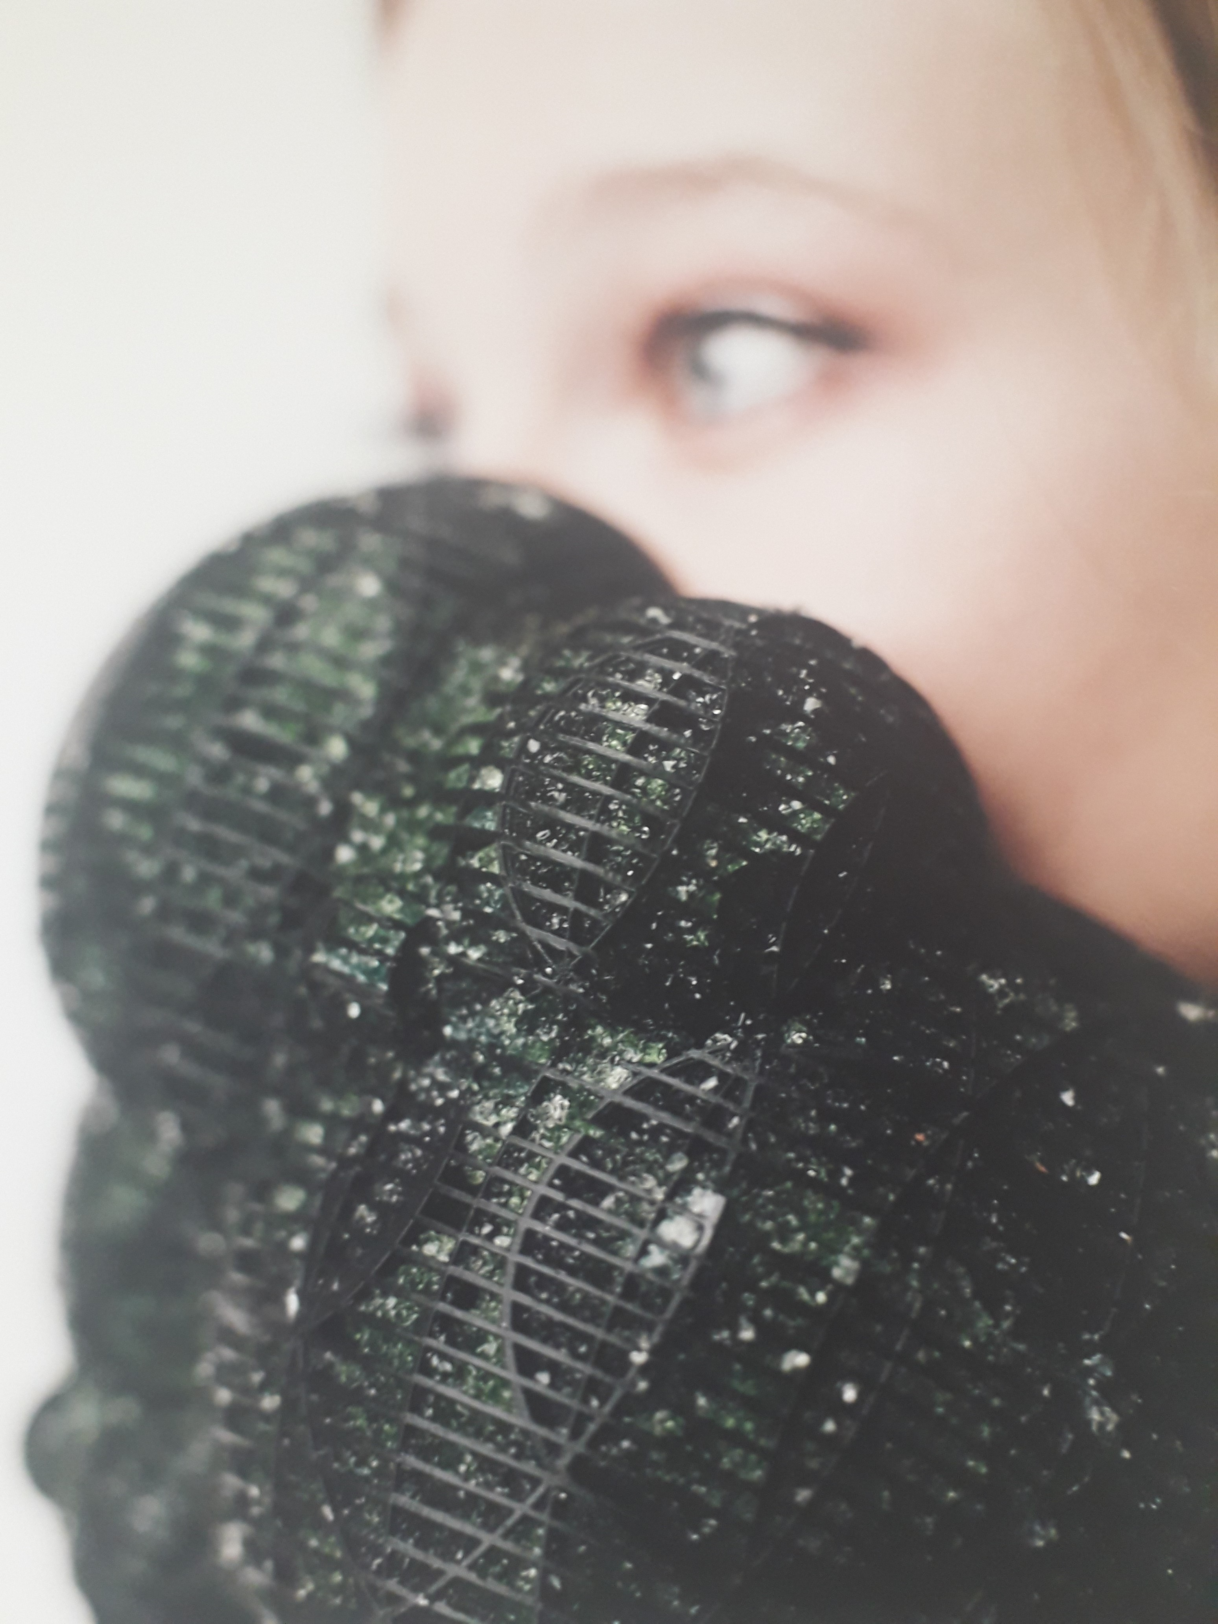
And Tre Seabourne focussed on the environment and how we can use material properties to create a more sustainable world through the many applications of modern technology.
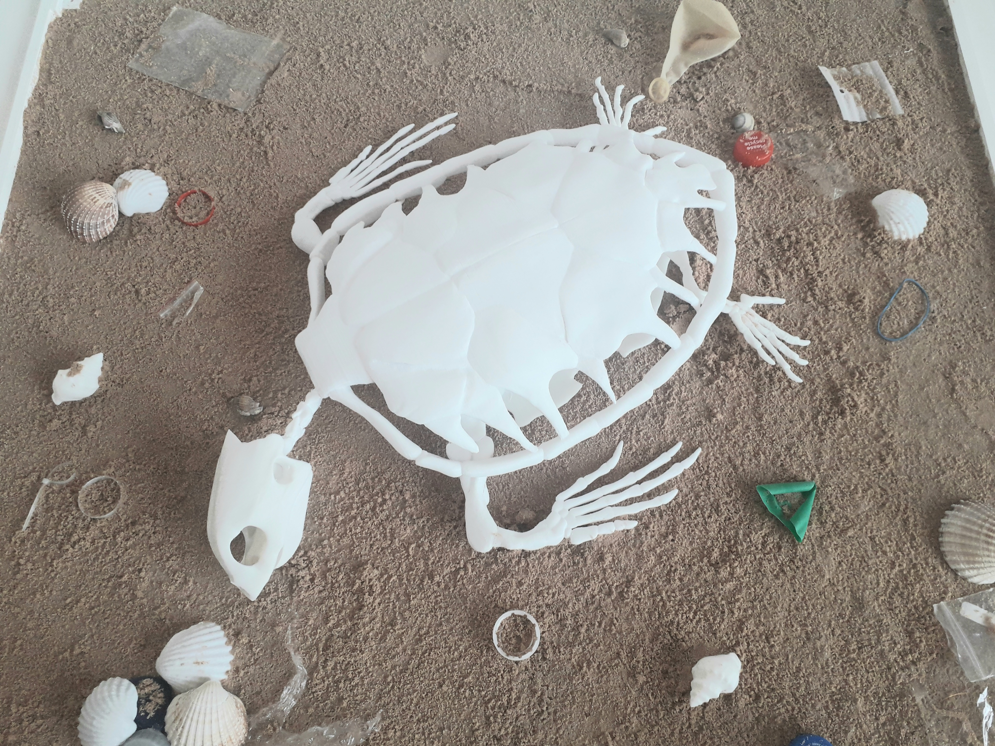
BLACKSMITHS
Blacksmith, Jonjoe Preston wrote about valuing quality and good workmanship with his beautifully crafted garden tools which invite practical use while telling a story. 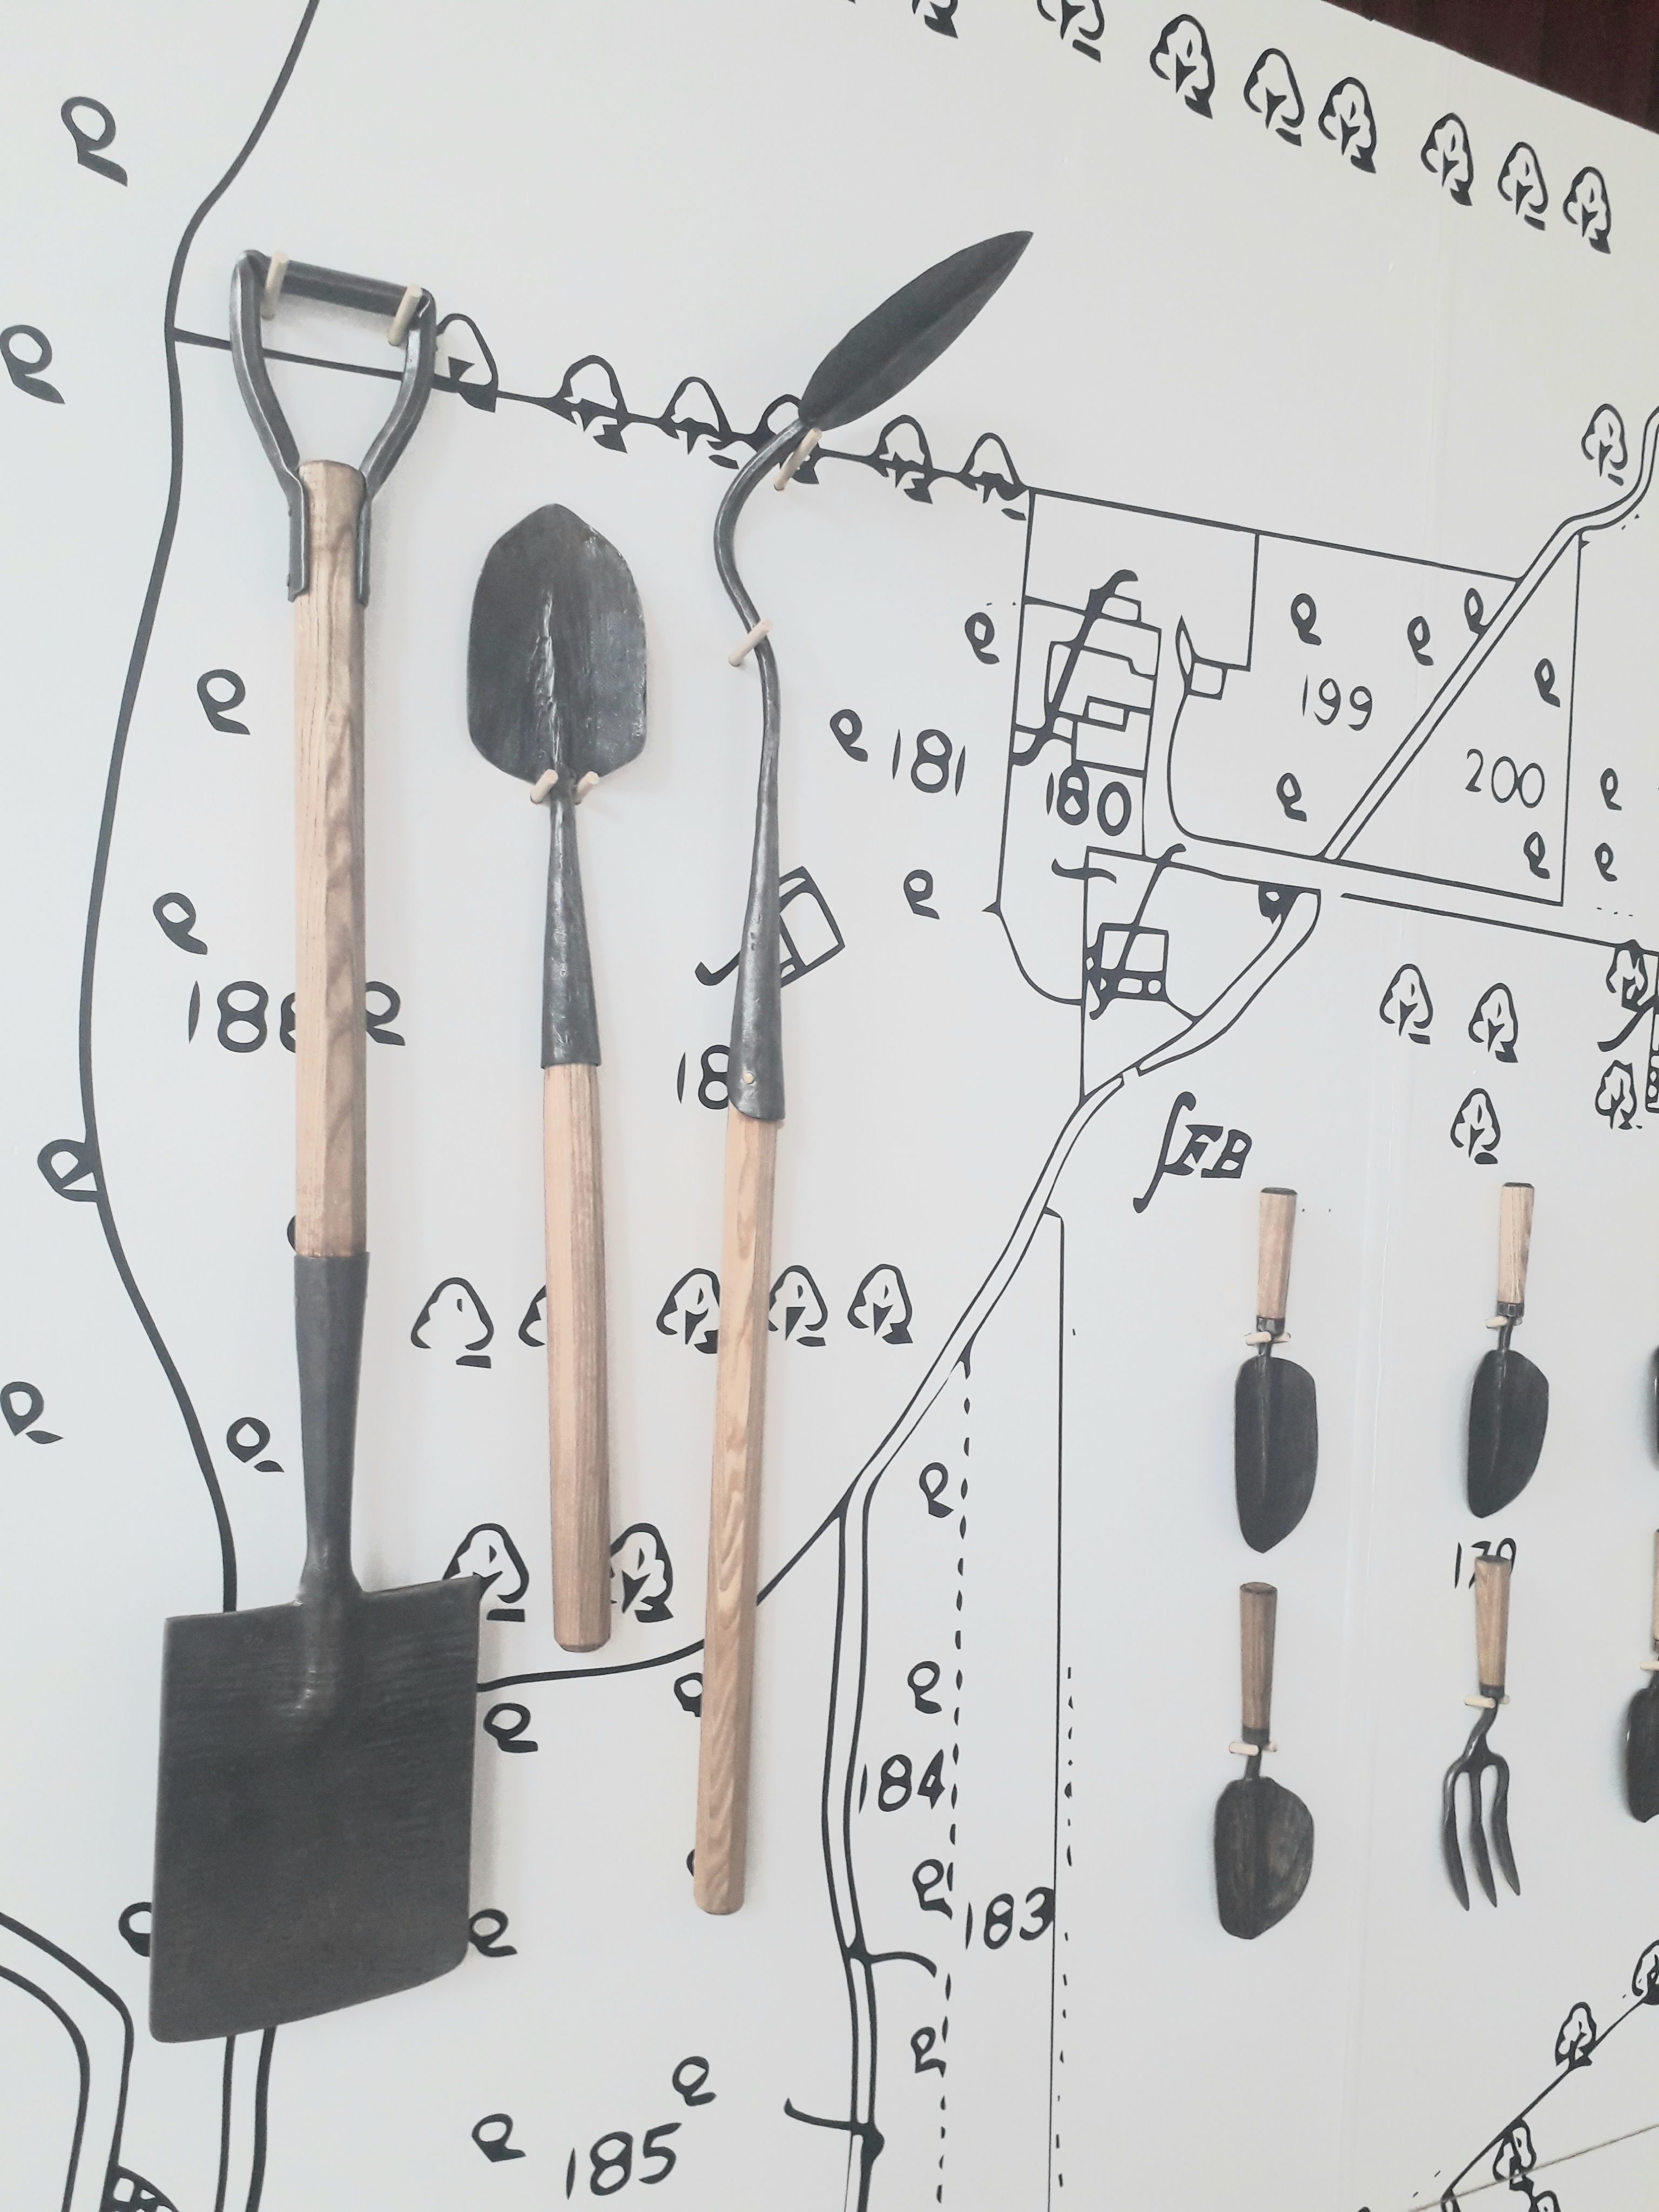
GRAPHICS
Hannah Jones
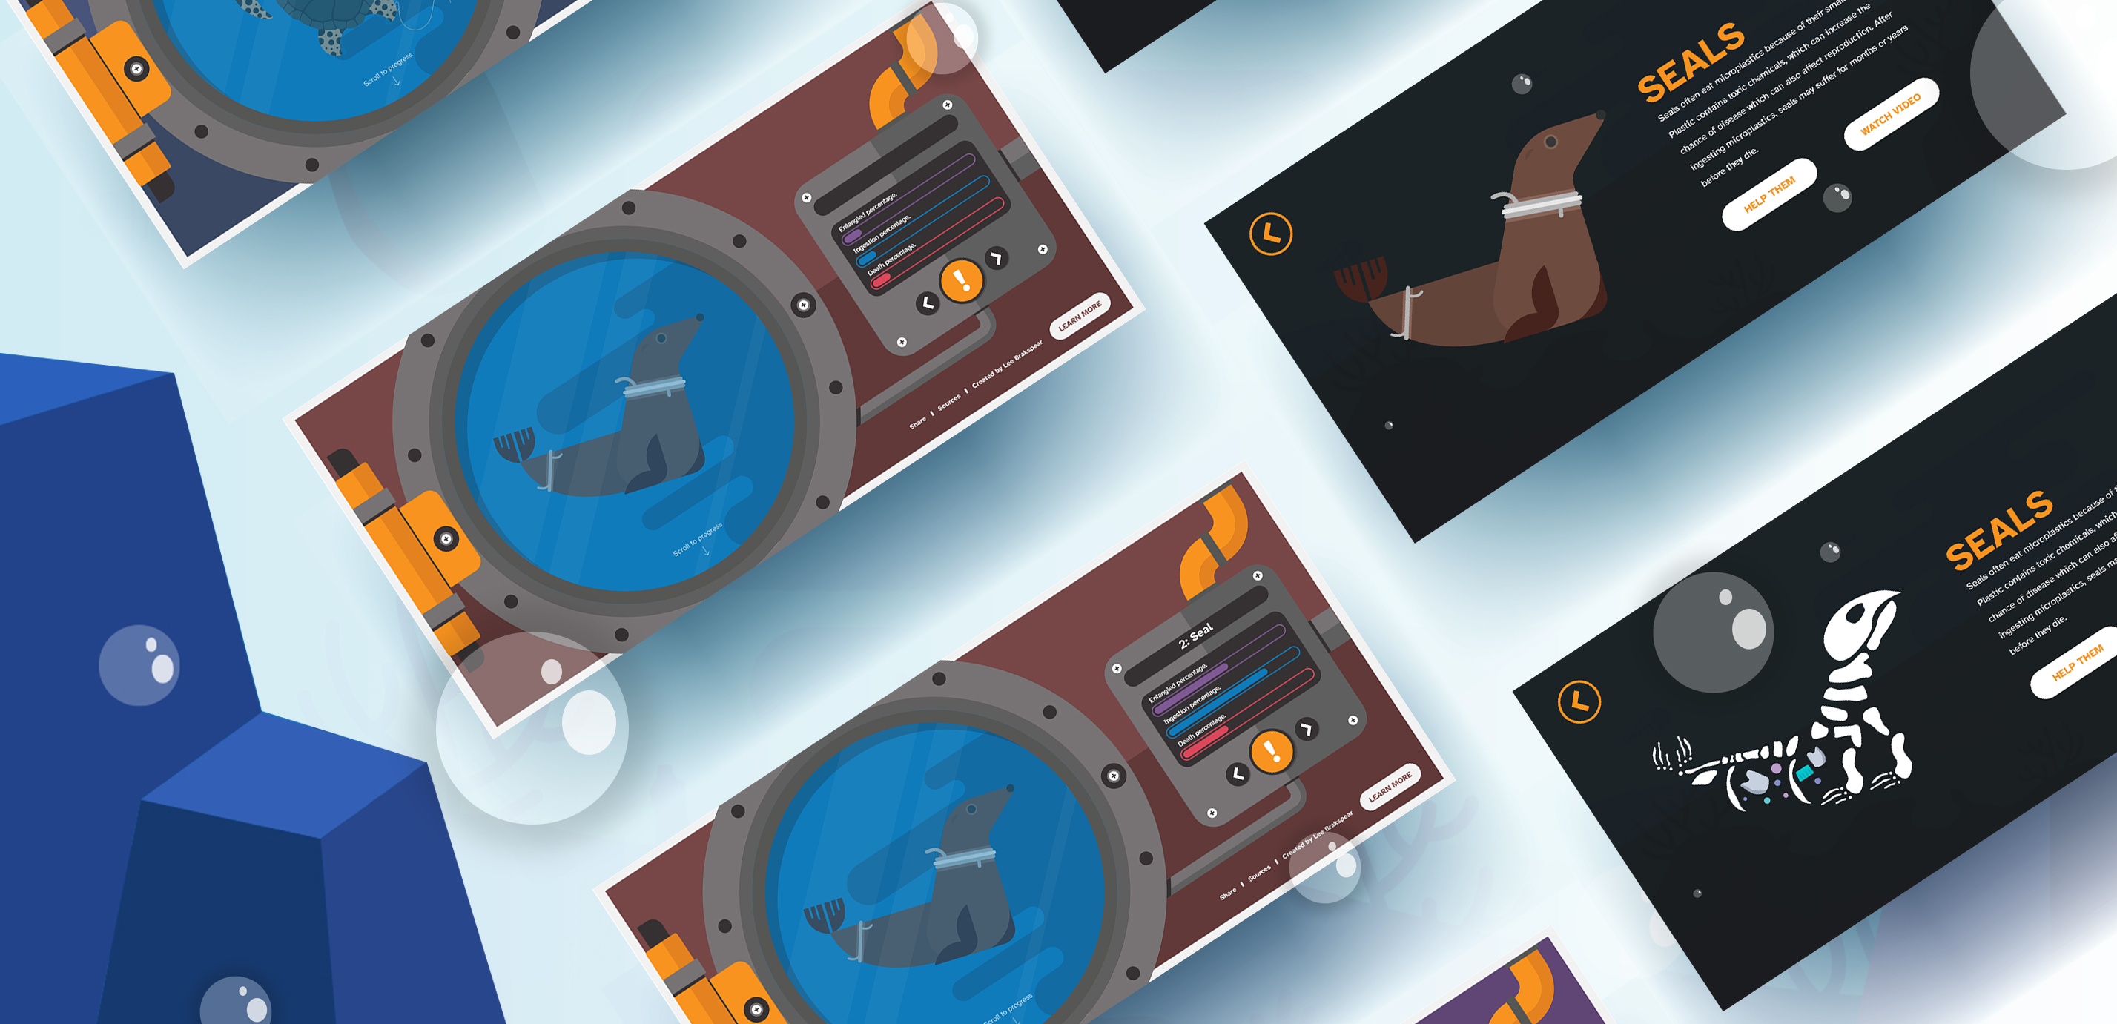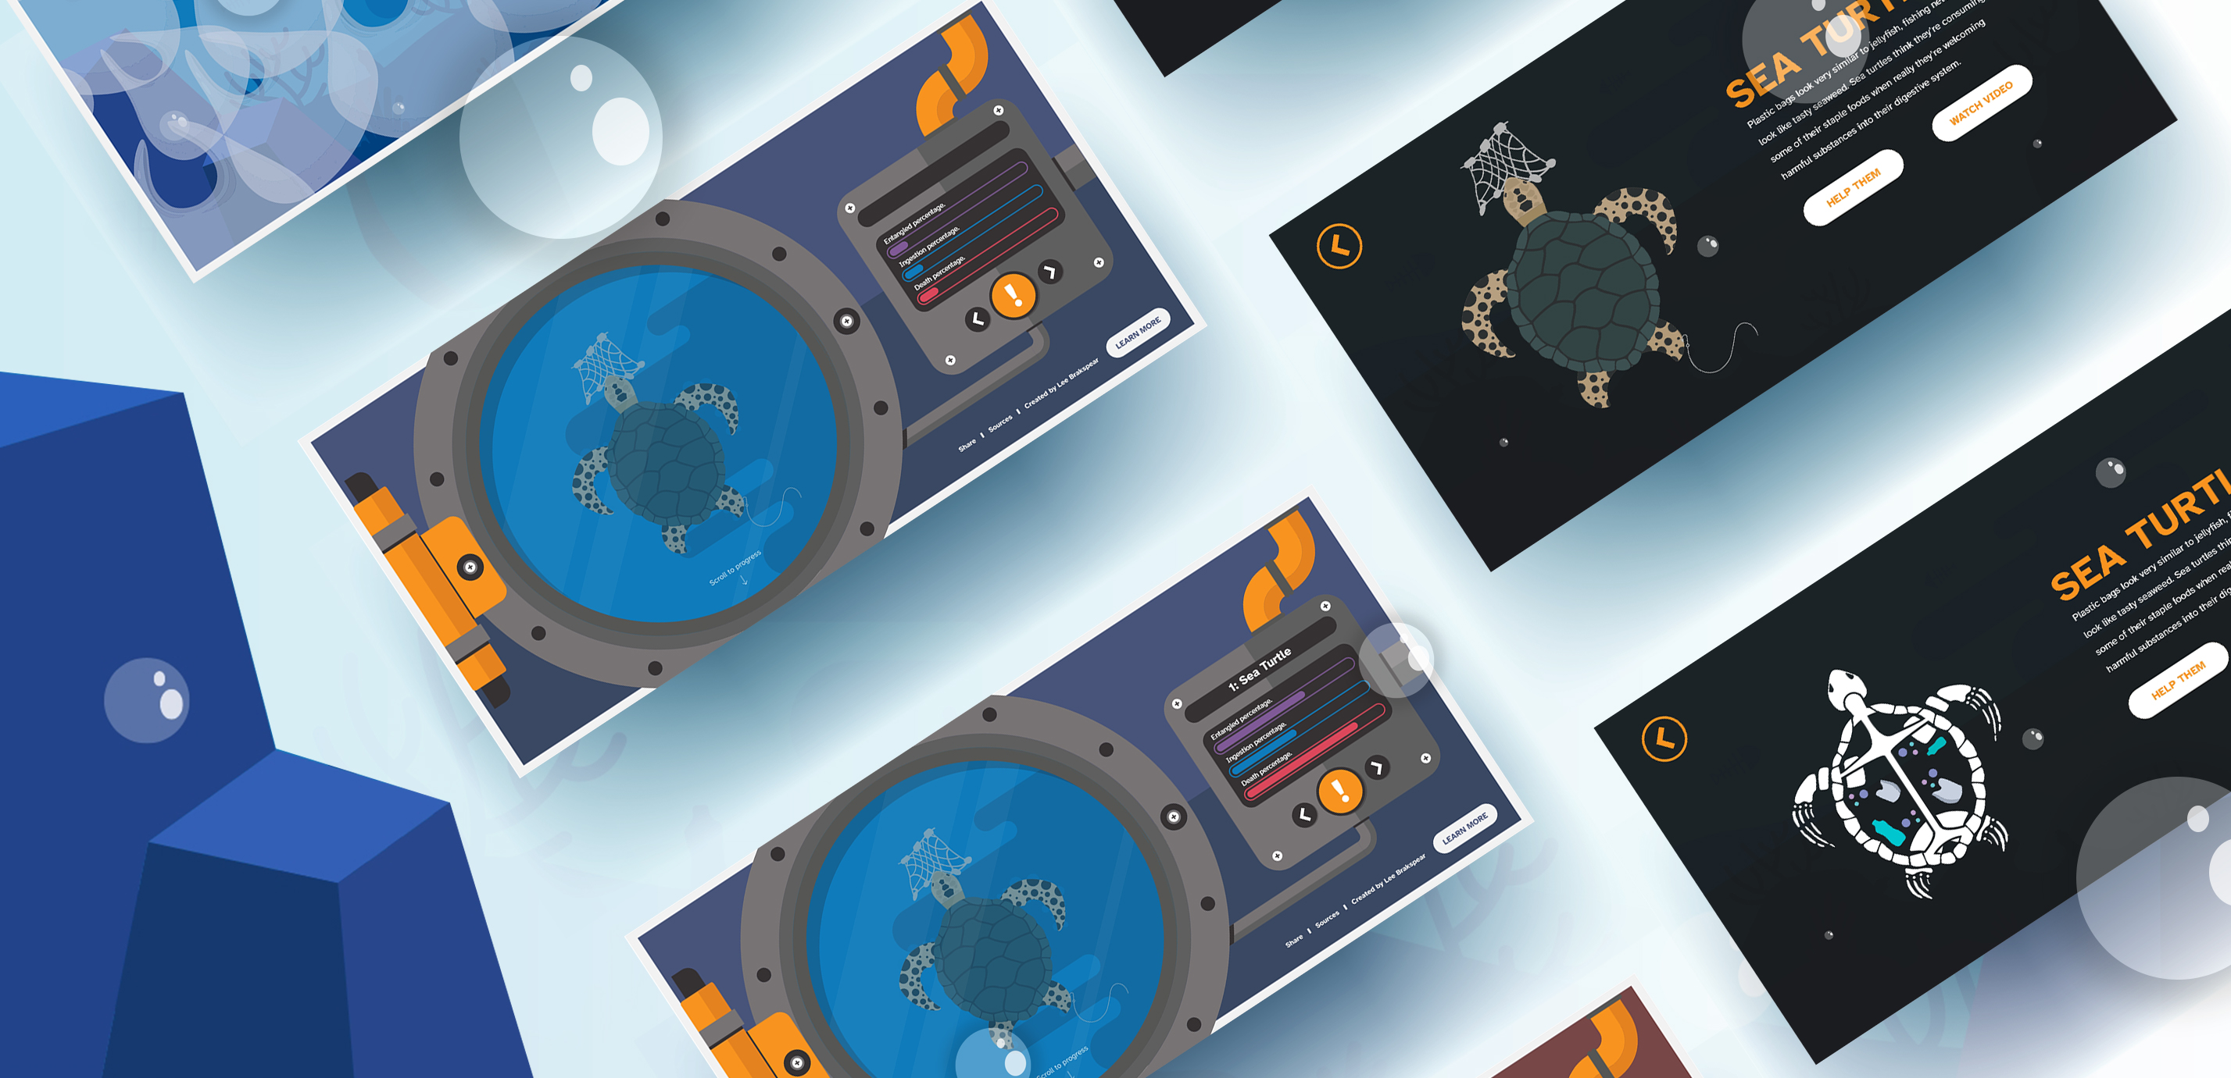
In Graphics, Lee Brakspear created an Ocean Pollution Website. He explains “This project was created to help educate younger people on the effects that ocean pollution has on our oceans. Millions of pieces of plastic end up in our oceans effecting the life of many marine animals that live in the habitat. Which is why this interactive experience was created. I wanted to create a website that would educate the viewers on what sort of animals are affected, and how that animal is affected. These stats are all followed by uniquely interactive designs & animations that come to life when viewed or have been interacted with by the user. Hovering over the animals also shows the amount of plastic that animal has ate and how these animals eating the plastic can also affect us.
ILLUSTRATION
Hannah Jones
In Illustration - Jema Mai-Roberts created Badlands Summer Camp to encourage sustainable living through art, and show how fun, easy and inexpensive it can be.
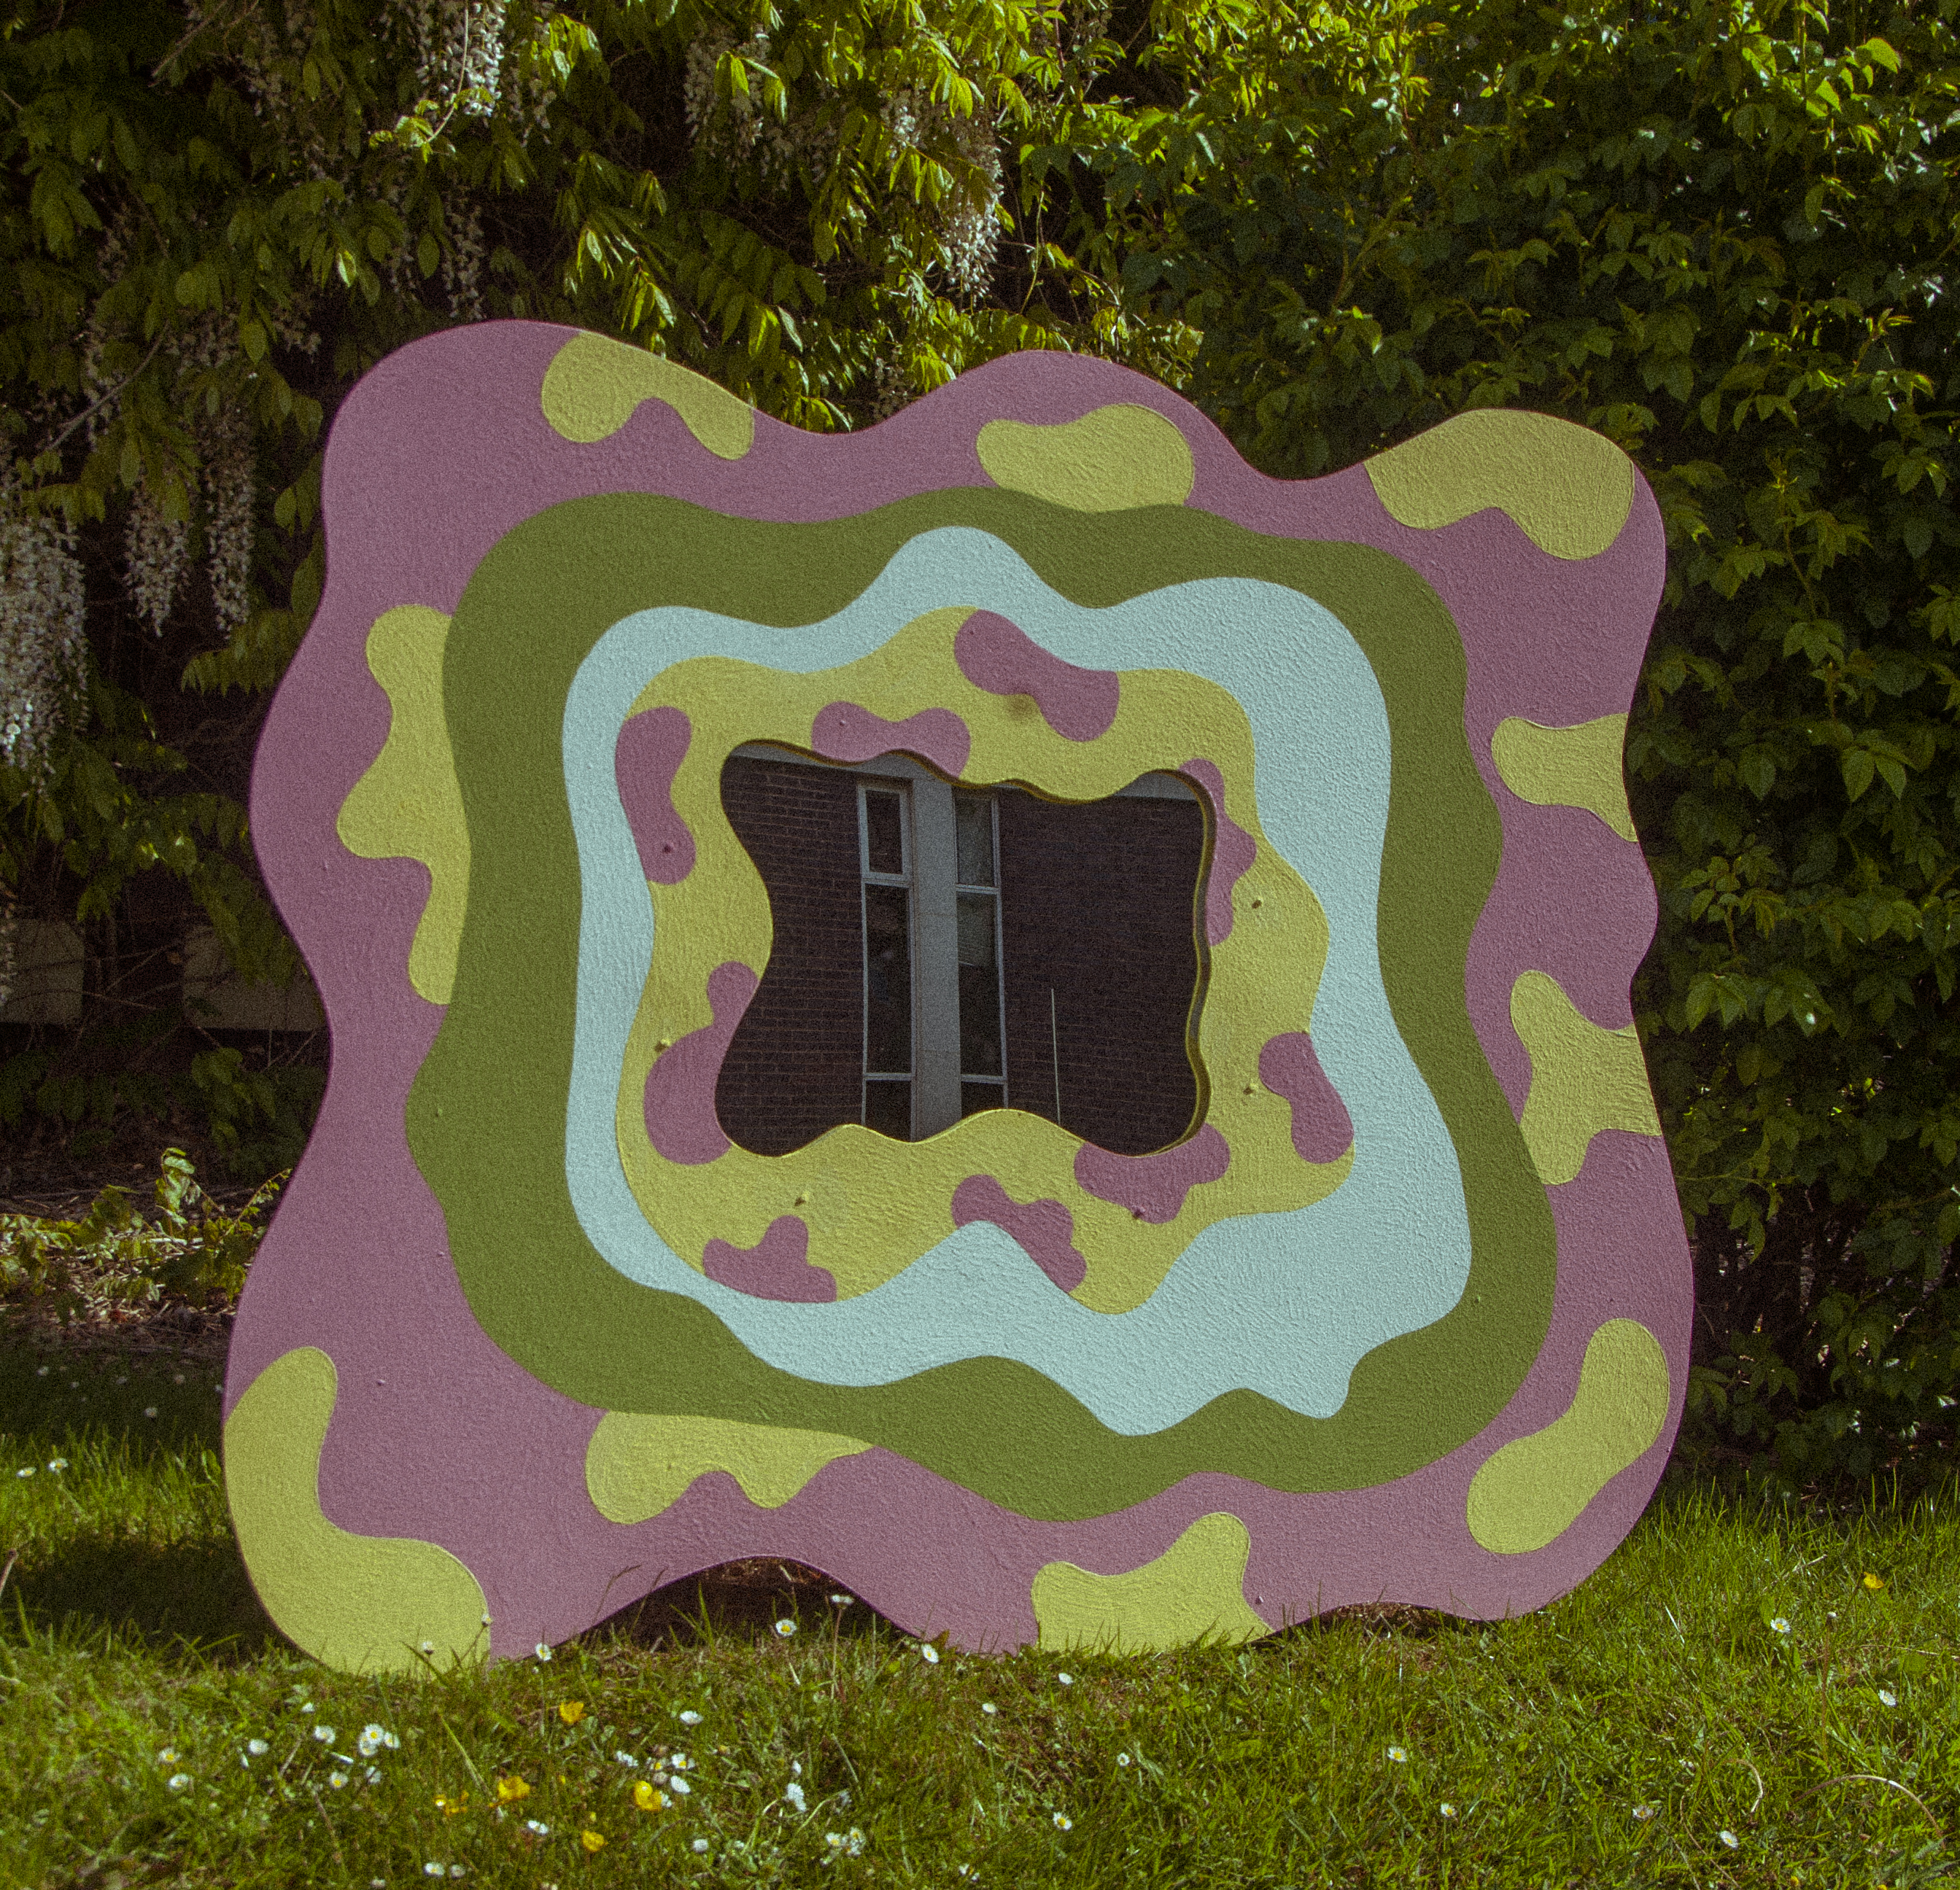
Jema explains “When designing my Summer Camp for my major project, I wanted to tie in examples of ways we can be sustainable while still enjoying and creating art. In my zine – which is Riso printed on campus, reduced air miles and more energy efficient and biodegradable inks!! – I included activities such as upcycling old clothes and making inks and paints from plants to encourage sustainability.
For the wooden cut-outs that decorate my Camp, I used found wood/ MDF, that was left over from other people’s projects/ in the scrap bin before I bought anything new. The paints that I used were also found, again either from past projects or ones that people had laying around and were gifted to me. The paints I used also have very low VOC levels, if any, and I did not varnish any of the pieces to maintain its sustainability.
Also, since I had smaller scrap pieces of wood after cutting out my big shapes, I re-cut some of it into little heart shapes which I then painted and sold in my shop to reduce waste. As for the actual cut-outs, I will be keeping them and either selling them or re-painting/ re-purposing them for other projects. They will not be scrapped. I still have wood and paints left over from the project and will continue to use them for my art to reduce waste and to create as sustainably as I can.”

highlights of FE final shows
Jess Bugler
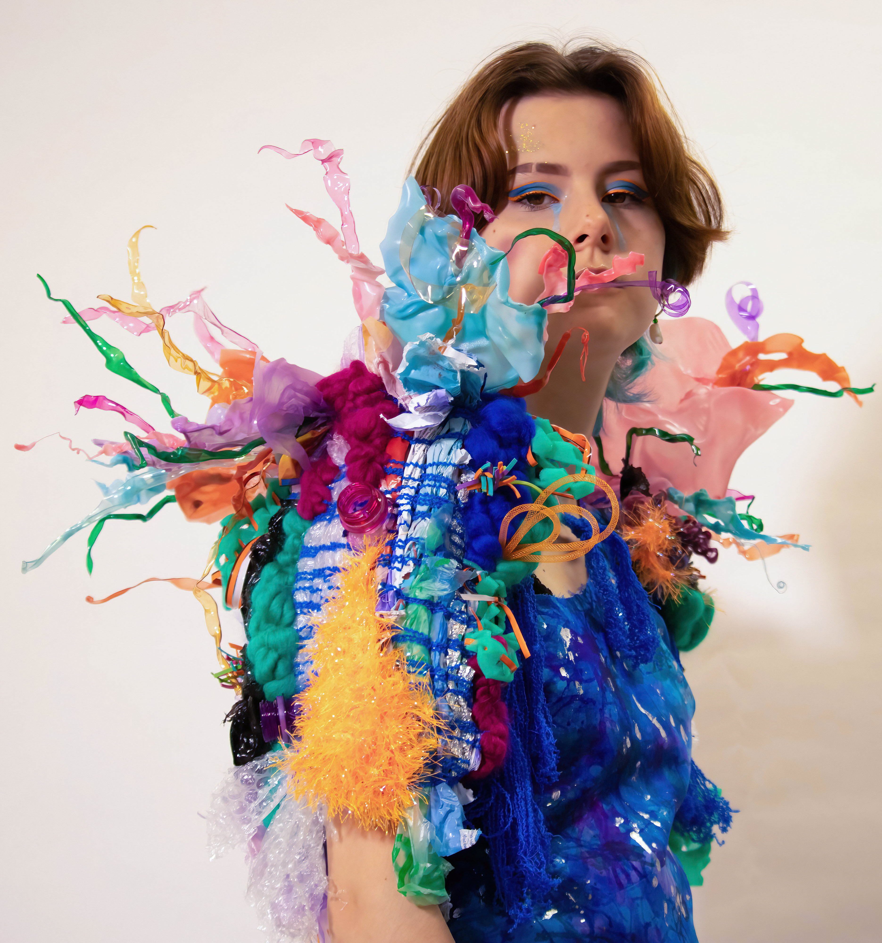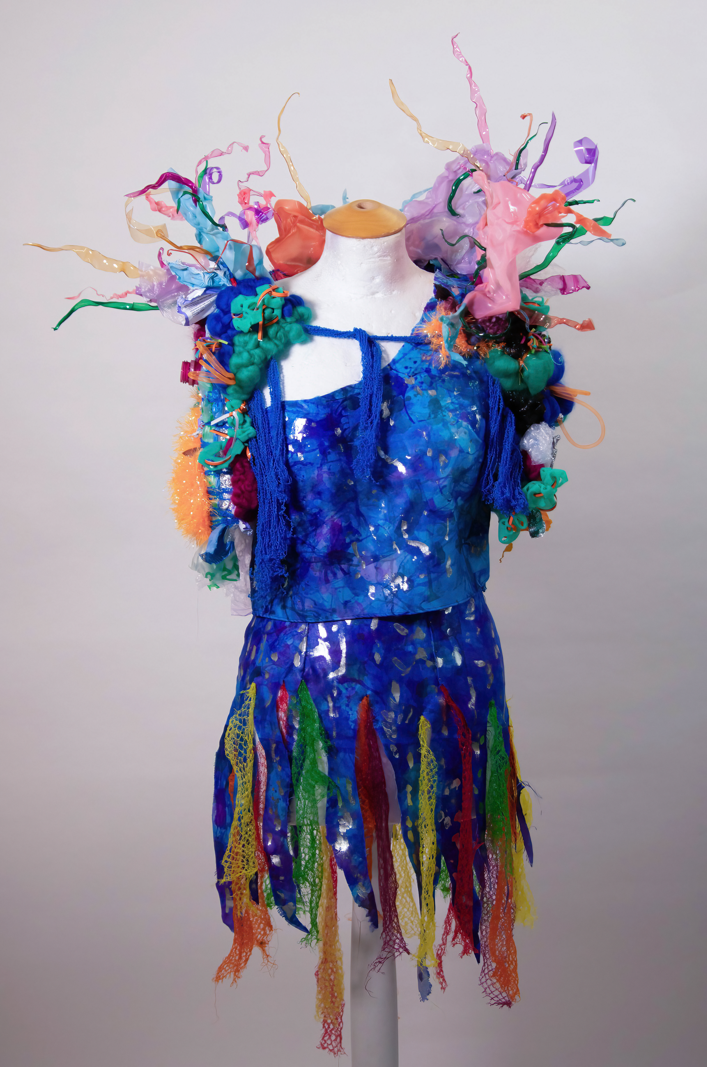
For her final show for Extended Diploma Art and Design, Melissa Sanders looked at the question of plastic waste in our Oceans in “The Great Plastic Pacific”. Melissa explains,
“Did you know, with the mass production of plastic; combined with our mishandling of waste, by 2050 there’ll be more plastic in our oceans than fish? The aim of my work is to reflect the suffering of one of our world’s most beautiful environments, through recycling household waste into sustainable textiles, reflecting how the home of marine life is being polluted.”
Elinor Grant from Foundation also created these brilliant Risograph zines for her final project, each one illustrating steps we can all take to reduce our Carbon footprint.
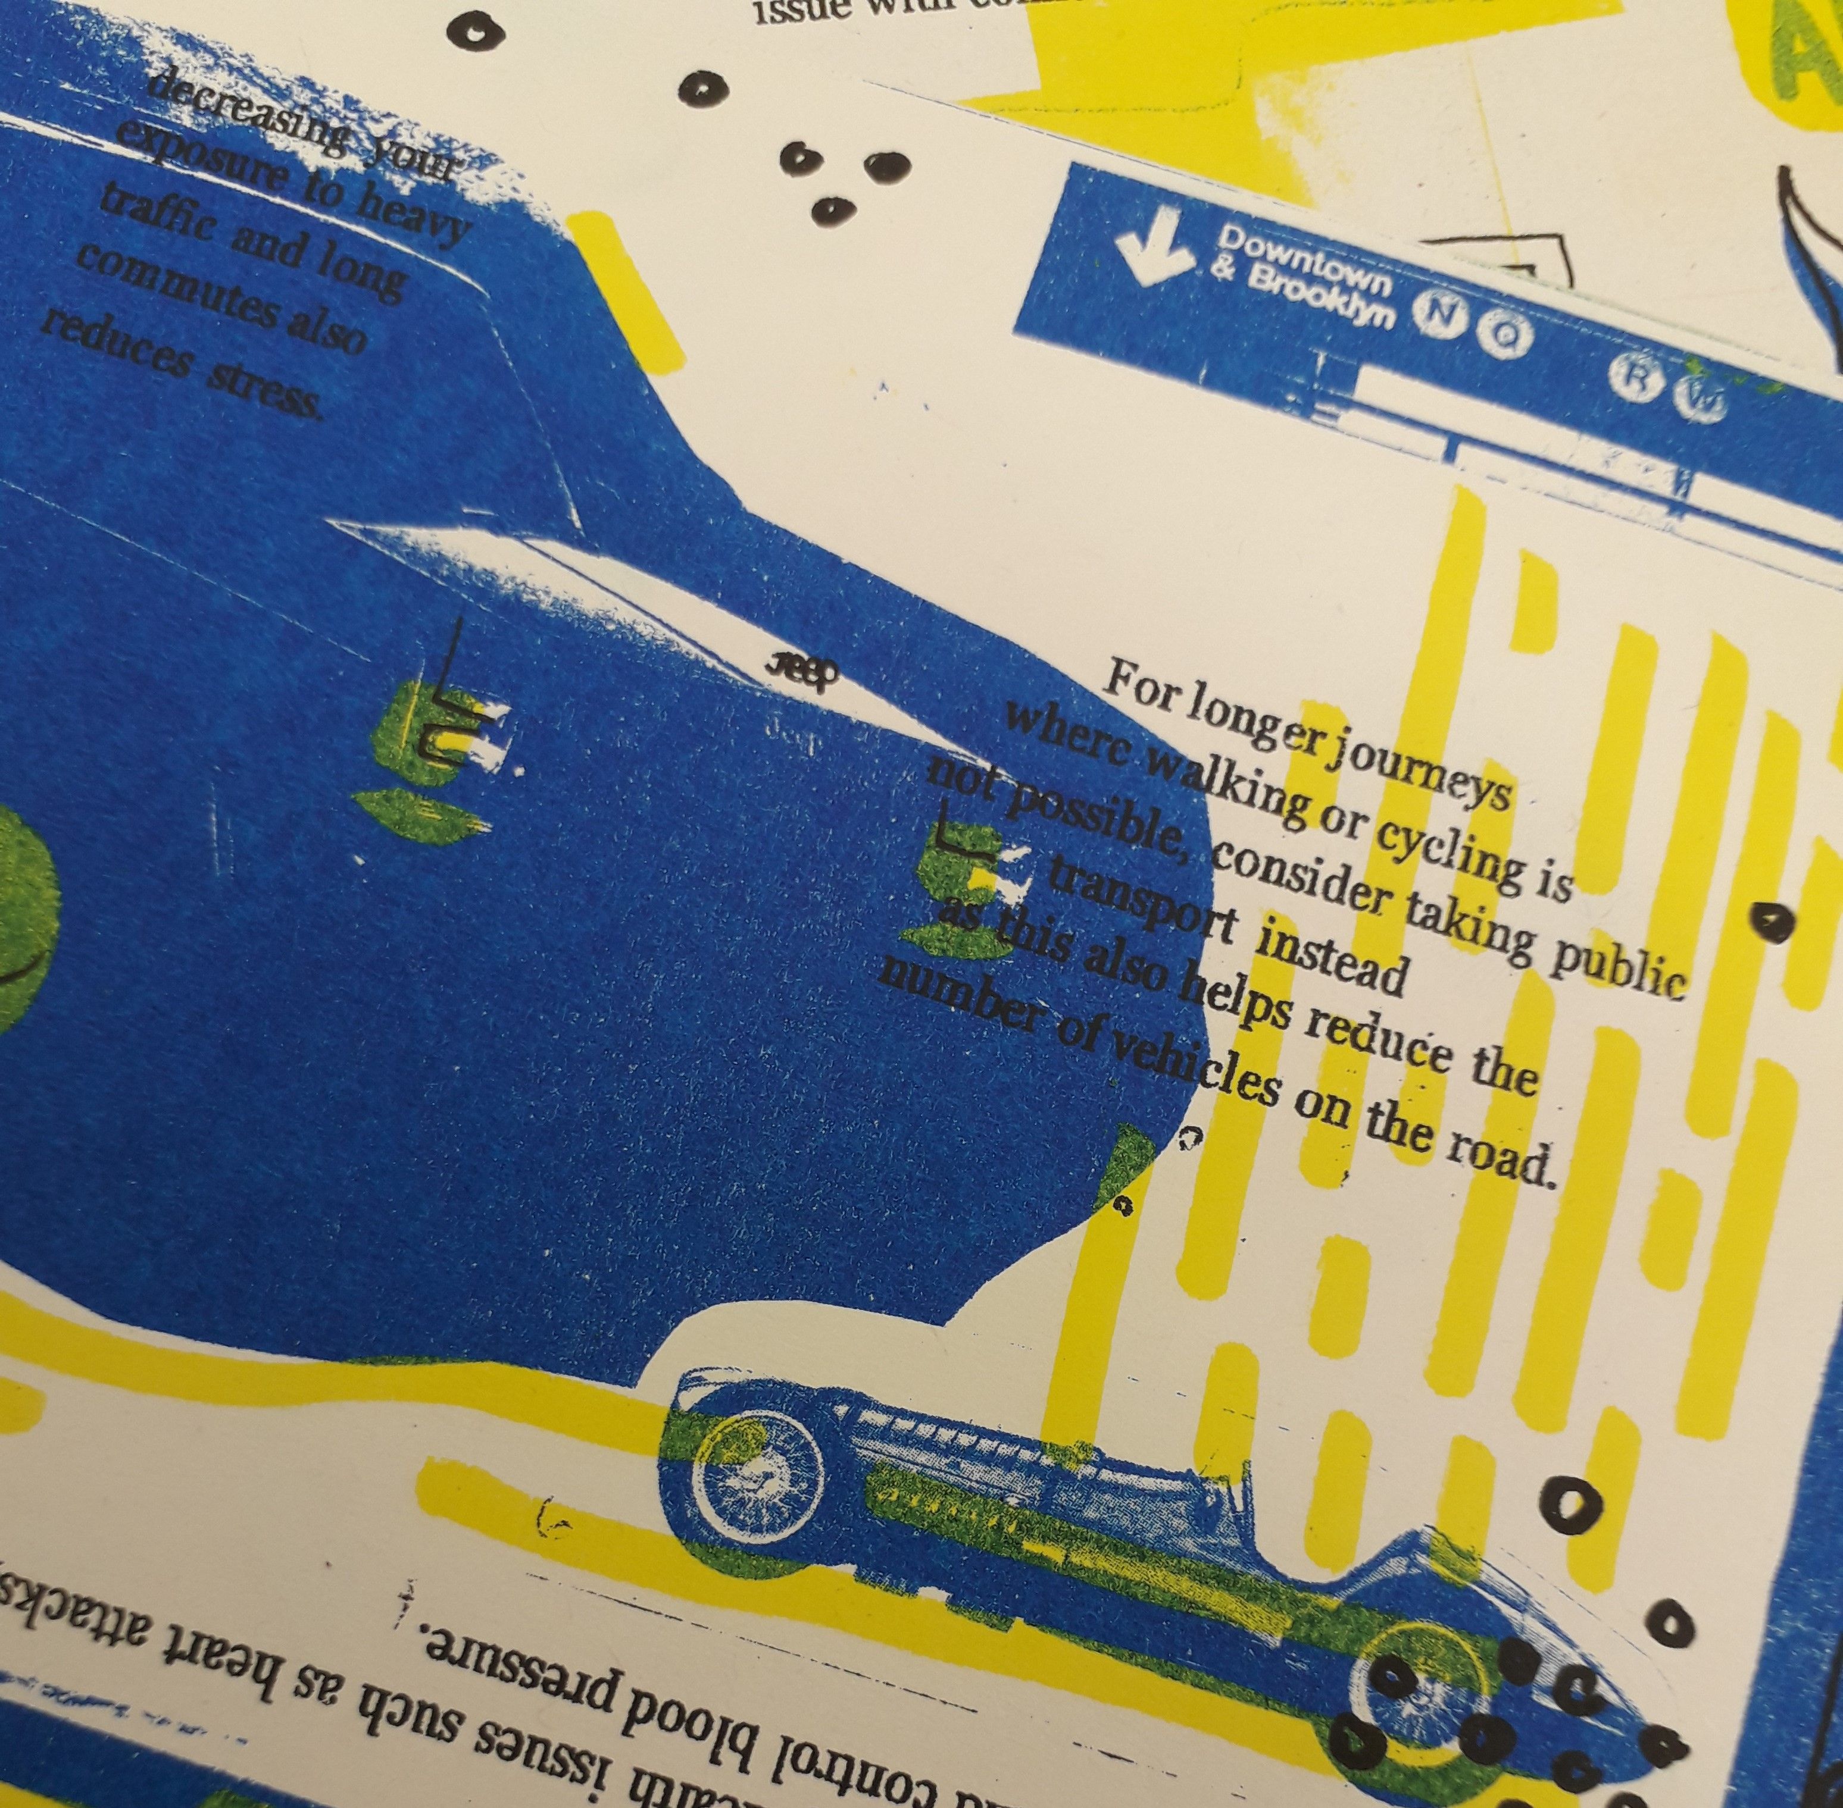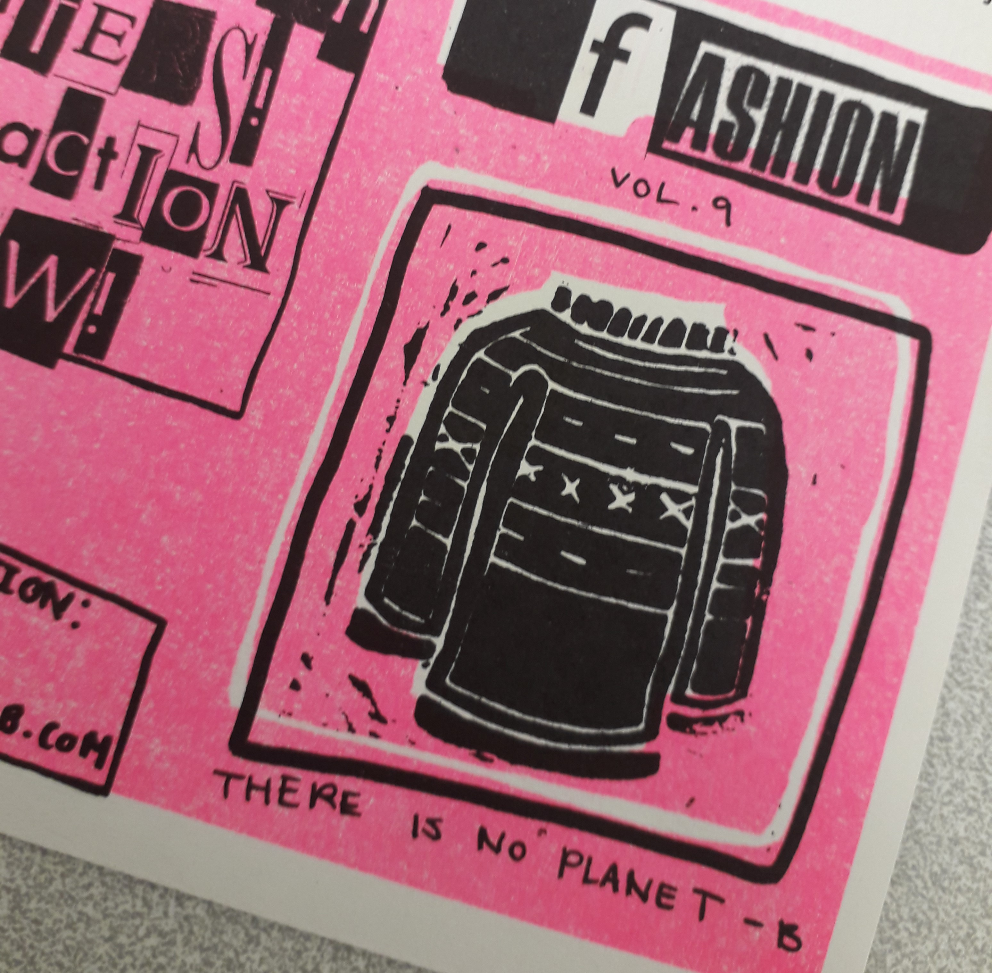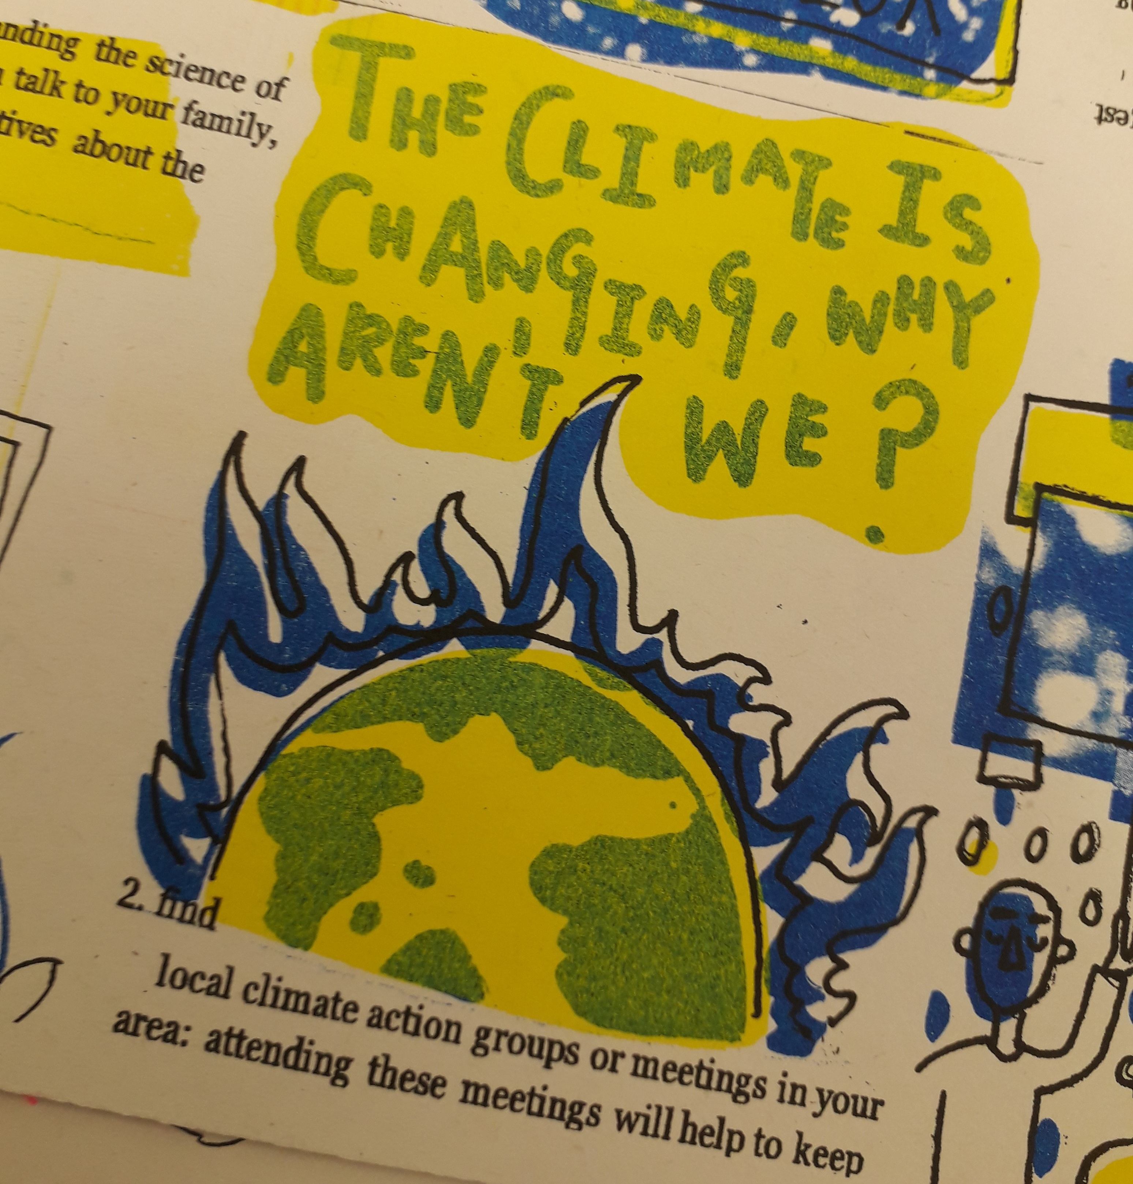
CONGRATULATIONS TO ALL STUDENTS FOR SUCH INSPIRING WORK!

Reminder of our progress this year...
- We have started on the Association of Colleges Climate Change Road Map as an Emerging College.
- We have carried out sustainability surveys, getting the views of staff and students.
- We have set up a staff and student sustainability committee, with regular meetings, a regular newsletter
- We have a Sustainability page on the HCA website with our Sustainability statement published there.
- We have started a trial of 100% recycled paper across both campuses – so please carry on requesting and using it whenever you can!
- We have a new Beryl bikes station.
- We have created sustainable practice codes for Students which are displayed across the college.
- We have carried out surveys of teaching staff, course leaders and workshop staff to see how Sustainability is embedded in HE.
- We have trialed some sustainable methods of hanging in this year’s final shows.
- We held fashion revolution week with talks on sustainability.
- We have started recyclable materials stores in College Road and Folly Lane.
- We have stickers designed by students and printed to remind staff and students to switch off and minimize energy use.
- We are working with Campus food suppliers to supply sustainable, local and vegan options.
- We planted 10 trees at Folly Lane Campus from Herefordshire Council’s City Trees scheme.
- We have had an Ecological survey carried out with recommendations for Folly Lane and College Road Campuses for steps to take to increase biodiversity.
So huge thanks to all staff and students involved for all your hard work.....
Next year.. we are looking forward to naming our Carbon 0 date, electing a student sustainability officer, trialing carbon literacy training and putting some of the suggestions from our ecological report into practice...
So please join the sustainability committee and help us be greener and act on the Climate Emergency.

ST Recommends…
Join the Herefordshire Wildlife Trust..... and you can get Wildlife magazine to read about some of the great steps to increase biodiversity going on across Herefordshire including HCA’s own drive for Sustainability on page 29.
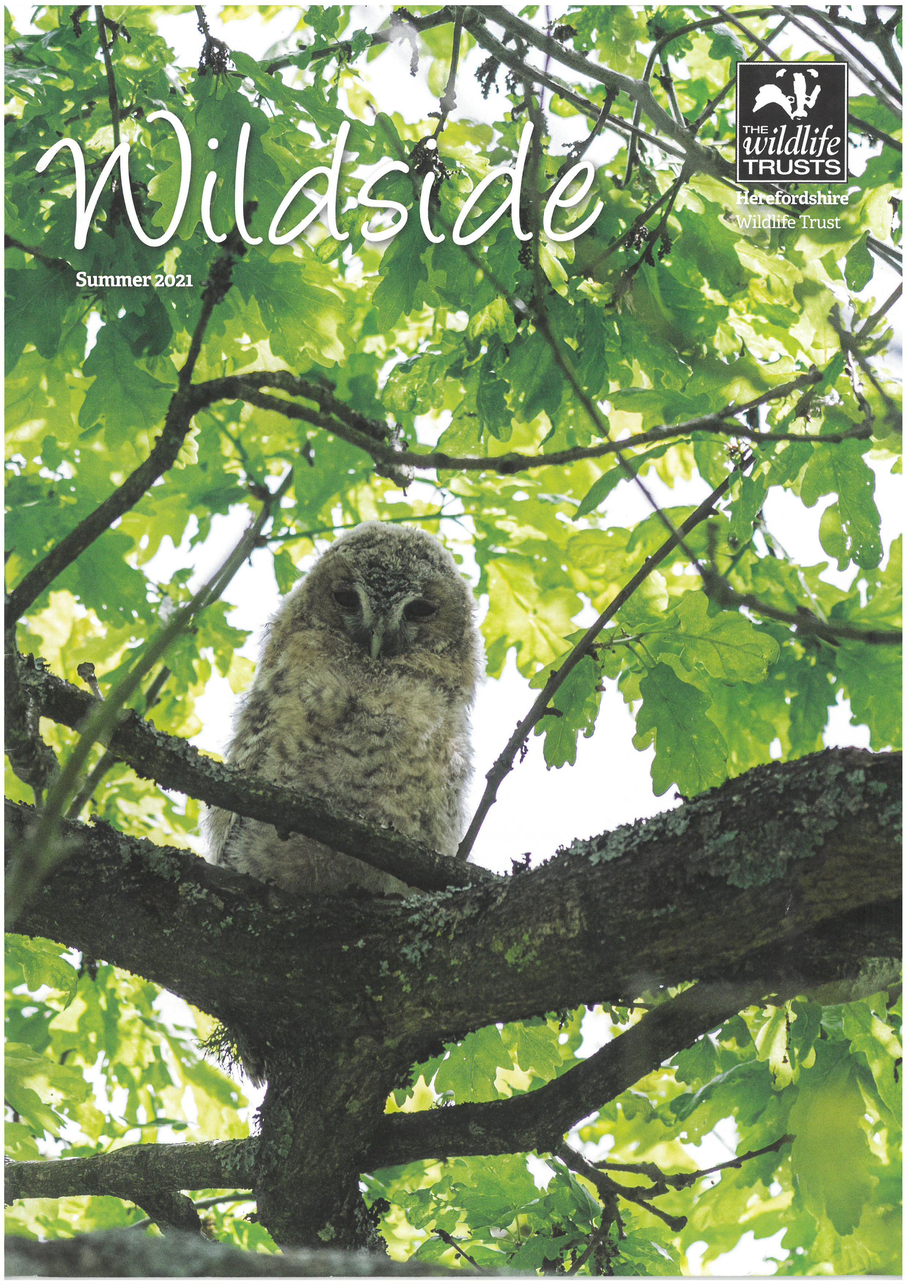
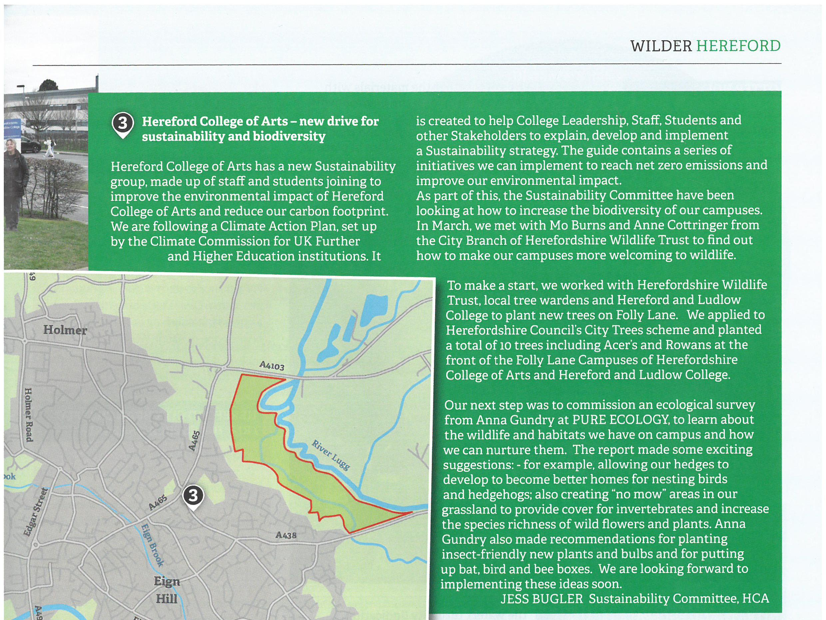

get in touch
Email us on sustainability@hca.ac.uk
Instagram @hca.sustainability
Join the team! Send us an email to get onboard and make a change…

