MA Photography, Landscape and the Environment

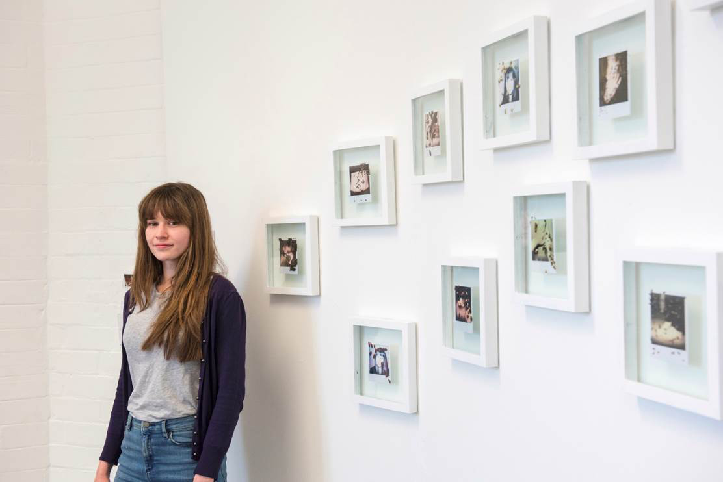

COURSE OVERVIEW

Programme Length | 24 Months, Part Time (90 weeks)  Semester 1/2: September to April/May  Semester 3/4: May/June to December  Semester 5/6: January to September
Location | On-line &  Hereford College of Arts, College Road Campus, Hereford
Student Numbers | Approx. 12-18
Teaching Days | - 1 days per week, Thursdays  - On-line but free access to facilities in Hereford  - Varied programme with Artist talks, Seminars, Tutorials  - Eminent associate tutor, Helen Sear
Facilities | - Use of all facilities i.e. studios, workshops, library, e-books  - Workshops: set times for on-line inductions and classes  - Photographic Studios and High end Scanner available
Room Resources | - Research spaces and IT available  - Lecture and seminar rooms
Entry Requirements | - Applicants should be (or about to become) graduates.  - Applicants should submit a short proposal and electronic portfolio.  - Graduates within art, design and media will be considered.  - Professional Photographers who wish to reposition their practice may also qualify.

CONTACT
Alex Thimm, Course Coordinator MA Photography a.thimm@hca.ac.uk

Key Facts

Start of Course – September
Day of study –Thursday (one day per week study mode – you will need to spend extra time to develop your photographic project)
- Activities – weekly programme with Seminars, Artist & Scientists and Campaigners talks, practical tasks, academic tasks, Group Critiques, Student presentations, 1to1 tutorials, Group Tutorials, Gallery/Festival visits tbc
- Annual Symposium in Hereford
- All activities on-line – but face to face tutorials at Campus available
- Tutors include staff at HCA and associate on-line tutors
- Facilities at CRC are free to access 5 days per week (inductions required)
- Equipment may be borrowed for 3 days at a time
- 3 x 60 credits Segments each leading to a qualification
- Final Degree show at Hereford College of Arts & On-line (and/or external Gallery)
Although the key focus of the programme is the Environment that includes much wider potential practice than ‘traditional’ Landscape Photography. Engagement with cultural, social and contemporary issues and personal interpretations of environments will lead and inspire photographic responses and the creation of work which could be documentary practice to fine art, mixed media and installations.

